**Integrating the Healthcare Enterprise**



**IHE Patient Care Coordination/Cardiology**

**Technical Framework Supplement**

**Cross Enterprise Cardiovascular Heart Team**

**Workflow Definition**

**(XCHT-WD)**

**Draft in preparation for Public Comment**

<The IHE Documentation Specialist will change the title to just “Draft for Public Comment” upon publication for public comment; leave “as is” until then.>

Date: April 27th, 2016

Author: Elena Vio ([evio@consorzioarsenal.it](mailto:evio@consorzioarsenal.it)), Mauro Zanardini ([mzanardini@consorzioarsenal.it](mailto:mzanardini@consorzioarsenal.it)), Glauco Brandolino ([gbrandolino@consorzioarseanal.it](mailto:gbrandolino@consorzioarseanal.it)), Claudio Saccavini (csaccavini@consorzioarsenal.it)

Email: [pcc@ihe.net](mailto:pcc@ihe.net), [cardiotech@ihe.net](mailto:cardiotech@ihe.net)

*The following two pages are only here for Public Comment review of the Supplement Template itself and will be deleted prior to publishing this document for use as a template.*

**Supplement Template Review – What’s new?**

* The purpose of this version of the Supplement Template is to incorporate CDA Content Modules into the Supplement Template. This includes significant changes to the Volume 1 (Profiles) material and the introduction of Volume 3 (Content Modules).
* Note that eventually this Supplement Template and Volume 3 Technical Framework shell will be expanded to include other Content Module definitions such as DICOM (Section 7) and the next technology (Volume 8), etc.

**Supplement Template Public Comment Review Instructions**

Comments can be made at <http://ihe.net/ihetemplates.cfm>.

**Open Issues and Questions**

None**Foreword**

This is a supplement to the IHE PCC and IHE Cardiology Technical Framework <VX.X>. Each supplement undergoes a process of public comment and trial implementation before being incorporated into the volumes of the Technical Frameworks.

*<For Public Comment:>*This supplement is published on <Month XX, 201x> for Public Comment. Comments are invited and may be submitted at [http://www.ihe.net/<domain>/<domain>comments.cfm](http://www.ihe.net/Technical_Framework/public_comment.cfm). In order to be considered in development of the Trial Implementation version of the supplement comments must be received by <Month XX, 201X>.

*<For Trial Implementation:>*This supplement is published for Trial Implementation on <Month XX, 201X> and may be available for testing at subsequent IHE Connectathons. The supplement may be amended based on the results of testing. Following successful testing it will be incorporated into the <Domain Name> Technical Framework. Comments are invited and may be submitted at [http://www.ihe.net/<domain>/<domain>comments.cfm](http://www.ihe.net/%3cdomain%3e/%3cdomain%3ecomments.cfm).

This supplement describes changes to the existing technical framework documents and where indicated amends text by addition (bold underline) or removal (bold strikethrough), as well as addition of new sections introduced by editor’s instructions to “add new text” or similar, which for readability are not bolded or underlined.

“Boxed” instructions like the sample below indicate to the Volume Editor how to integrate the relevant section(s) into the relevant Technical Framework volume.

Replace Section X.X by the following:

<Instructions to authors are encapsulated in angled brackets as “< … >” and denoted with italicized text. These instructions are to be deleted in their entirety prior to publication.>

<This Supplement Template is intended for the development of new Profiles. Simple changes or updates to existing Supplements or Profiles should be made using the Change Proposal process. However, the addition of formal Options and significant changes may not be made using the Change Proposal process. In this latter case, this Supplement Template should be used, but a paragraph should be added to the Forward and to the Introduction to the Supplement explaining the situation. Also, see the Technical Framework Development section at <http://wiki.ihe.net/index.php?title=Process#Technical_Framework_Development> for more guidance on CPs versus new Supplements.>

<All of the sections in this document are required. Sections may not be deleted. The outline numbering is intended to be consistent across Profiles and across Domains, so do not adjust the outline numbering. If there is no relevant content for a section, simply state “Section not applicable”, but leave the numbering intact. Sub-sections may be added for clarity.>

<Use of capitalization: Please follow standard English grammar rules-only proper nouns and names are upper case. For example, “Modality Actor” is upper case, but “an actor which fulfills the role of a modality” is lower case. Do not use upper case to emphasize a word/topic.>

*<This Supplement Template includes templates for Volumes 1 (Profiles), 2 (Transactions), 3 (Content Modules), and 4 (National Extensions). Volumes 1, 2, and/or 3 are developed together for Public Comment and Trial Implementation submission. Volume 4, National Extensions, is typically developed at a later point in time, usually at Trial Implementation or later. Templates for all four volumes are included in this document for the sake of completeness. If you are beginning a new profile, you are strongly discouraged from using National Extensions and should instead focus on optional data sets or other alternatives. For more information, see* [*http://wiki.ihe.net/index.php?title=National_Extensions_Process*](http://wiki.ihe.net/index.php?title=National_Extensions_Process)*.>*

General information about IHE can be found at: [www.ihe.net](http://www.ihe.net)

Information about the IHE <Domain Name> domain can be found at: <http://www.ihe.net/Domains/index.cfm>

Information about the structure of IHE Technical Frameworks and Supplements can be found at: <http://www.ihe.net/About/process.cfm> and <http://www.ihe.net/profiles/index.cfm>

The current version of the IHE Technical Framework can be found at: <http://www.ihe.net/Technical_Framework/index.cfm>

Should a form of this stay after publication? Comments may be submitted on IHE Technical Framework templates at any time at <http://ihe.net/ihetemplates.cfm>. Please enter any comments/issues as soon as they are found. Do not wait until a future review cycle is announced.

Contents

Open Issues and Questions 11

Closed Issues 11

<*Copyright Permission>* 12

<*Domain-specific additions>* 12

X.1 XCHT-WD Actors, Transactions, and Content Modules 14

X.1.1 Actor Descriptions and Actor Profile Requirements 15

X.1.1.1 Heart Team Requester 15

X.1.1.2 Heart Team Manager 16

X.1.1.3 Heart Team Participant 16

X.2 XCHT-WD Actor Options 16

X.3 XCHT-WD Required Actor Groupings 16

X.4 XCHT-WD Overview 18

X.4.1.1 Heart Team 19

X.4.1.2 HT Documents 20

X.4.1.4 Delivery of Notifications 26

X.4.1.4.1 Workflow Status Update Notification for the HT Requester 27

X.4.1.4.3 HT Lead Workflow Task Assignment Notification 27

X.4.1.4.3 Workflow Status Update Notification for the HT Manager 28

X.4.1.4.4 HT Involvement Workflow Task Assignment Notification 28

X.4.1.4.5 Workflow Status Update Notification for the HT Participant 29

X.4.2 Use Cases 29

X.4.2.1 Use Case #1: Basic Heart Team Coordination 30

X.4.2.1.1 Basic Heart Team Coordination Use Case Description 30

X.4.2.1.2 Basic Heart Team Coordination Process Flow 33

X.4.2.2 Use Case #2: Complex Heart Team Coordination 37

X.4.2.2.2 Complex Heart Team Coordination Process Flow 39

X.4.2.3 Exception #1: Heart Team Cancellation Scenario 43

X.4.2.3.2 HT Cancellation Process Flow 44

X.4.2.4 Exception 2# Heart Team Assignment Cancellation 46

X.5 XCHT-WD Security Considerations 49

X.6 XCHT-WD Cross Profile Considerations 50

3.Y1 Submit and assign HT Management [PCC-Y1] 55

3.Y1.1 Scope 55

3.Y1.2 Actor Roles 55

3.Y1.3 Referenced Standards 55

3.Y1.4 Interaction Diagram 56

3.Y1.4.1 Submit and assign HT Management 56

3.Y1.4.1.1 Trigger Events 56

The information needed are: 57

3.Y1.4.1.2 Message Semantics 57

3.Y1.4.1.2.1 Heart Team Workflow Document Content Requirements 57

3.Y1.4.1.2.1.1 Workflow Document Elements 58

3.Y1.4.1.2.1.1.1 Workflow Document taskList Element 58

3.Y1.4.1.2.1.1.1.1 XDW Task “HT Request” 58

3.Y1.4.1.2.1.1.1.2 XDW Task “HT Lead” 59

3.Y1.4.1.2.2 HT Request Document Content Requirements 60

3.Y1.4.1.2.3 Document Sharing Metadata Requirements 60

3.Y1.4.1.3 Expected Actions 61

3.Y1.4.2 Provide And Register Document set-b Response 61

3.Y1.4.2.1 Trigger Events 62

3.Y1.4.2.2 Message Semantics 62

3.Y1.4.2.3 Expected Actions 62

3.Y1.5 Security Considerations 62

See section ITI TF-2b:3.41.5. 62

3.Y1.5.1 Security Audit Considerations 62

See section ITI TF-2b:3.41.5.1. 62

3.Y2 Accept/Reject HT Activity PCC-Y2 62

3.Y2.1 Scope 62

3.Y2.2 Actor Roles 63

3.Y2.3 Referenced Standards 63

3.Y2.4 Interaction Diagram 63

3.Y2.4.1 Accept/Reject HT Activity 64

3.Y2.4.1.1 Trigger Events 64

3.Y2.4.1.2 Message Semantics 65

3.Y2.4.1.2.1 Heart Team Workflow Document Content Requirements 65

3.Y2.4.1.2.1.1 Workflow Document Elements 65

3.Y2.4.1.2.1.1.1 XDWTask “HT Lead” 65

3.Y2.4.1.2.1.1.2 XDWTask “HT Involvement” 66

3.Y2.4.1.2.2 Document Sharing Metadata requirements 66

3.Y2.4.1.3 Expected Actions 67

3.Y2.4.2 Provide and Register Document set-b Response 67

3.Y2.4.2.1 Trigger Events 67

3.Y2.4.2.2 Message Semantics 67

3.Y2.4.2.3 Expected Actions 67

3.Y2.5 Security Considerations 68

See ITI TF-2b:3.41.5. 68

3.Y2.5.1 Security Audit Considerations 68

See ITI TF-2b:3.41.5.1. 68

3.Y3 Assign HT Participation [PCC-Y3] 68

3.Y3.1 Scope 68

3.Y3.2 Actor Roles 68

3.Y3.3 Referenced Standards 69

3.Y3.4 Interaction Diagram 69

3.Y3.4.1 Assign HT Participation 69

3.Y3.4.1.1 Trigger Events 69

3.Y3.4.1.2 Message Semantics 70

3.Y3.4.1.2.1 Heart Team Workflow Document Content Requirements 70

3.Y3.4.1.2.1.1 Workflow Document Elements 70

3.Y3.4.1.2.1.1.1 Workflow Document taskList Element 70

3.Y3.4.1.2.1.1.1.1 XDW Task “HT Invitation” 70

3.Y3.4.1.2.2 Document Sharing Metadata Requirements 71

3.Y3.4.1.3 Expected Actions 72

3.Y3.4.2 Provide And Register Document set-b Response 72

3.Y3.4.2.1 Trigger Events 72

3.Y3.4.2.2 Message Semantics 72

3.Y3.4.2.3 Expected Actions 72

3.Y3.5 Security Considerations 73

See section ITI TF-2b:3.41.5. 73

3.Y3.5.1 Security Audit Considerations 73

See section ITI TF-2b:3.41.5.1. 73

3.Y4 Add request of more clinical information [PCC-Y4] 73

3.Y4.1 Scope 73

3.Y4.2 Actor Roles 73

3.Y4.3 Referenced Standards 74

3.Y4.4 Interaction Diagram 74

3.Y4.4.1 Add Request of more clinical information 74

3.Y4.4.1.1 Trigger Events 74

The information needed is: 75

3.Y4.4.1.2 Message Semantics 75

3.Y4.4.1.2.1 Heart Team Workflow Document Content Requirements 75

3.Y4.4.1.2.1.1 Workflow Document Elements 75

3.Y4.4.1.2.1.1.1 Workflow Document taskList Element 75

3.Y4.4.1.2.1.1.1.1 XDW Task “HT Preparation” 76

3.Y4.4.1.2.2 Request of more information document Content Requirements 76

3.Y4.4.1.2.3 Document Sharing Metadata Requirements 76

3.Y4.4.1.3 Expected Actions 77

3.Y4.4.2 Provide And Register Document set-b Response 77

3.Y4.4.2.1 Trigger Events 77

3.Y4.4.2.2 Message Semantics 78

3.Y4.4.2.3 Expected Actions 78

3.Y4.5 Security Considerations 78

See section ITI TF-2b:3.41.5. 78

3.Y4.5.1 Security Audit Considerations 78

See section ITI TF-2b:3.41.5.1. 78

3.Y5 Add more clinical information [PCC-Y5] 78

3.Y5.1 Scope 78

3.Y5.2 Actor Roles 78

3.Y5.3 Referenced Standards 79

3.Y5.4 Interaction Diagram 79

3.Y5.4.1 Add more clinical information 79

3.Y5.4.1.1 Trigger Events 80

The information needed are one or more of these: 80

3.Y5.4.1.2 Message Semantics 80

3.Y5.4.1.2.1 Heart Team Workflow Document Content Requirements 80

3.Y5.4.1.2.1.1 Workflow Document Elements 81

3.Y5.4.1.2.1.1.1.1 XDW Task “HT Preparation” 81

3.Y5.4.1.2.2 Document Sharing Metadata Requirements 81

3.Y5.4.1.3 Expected Actions 82

3.Y5.4.2 Provide And Register Document set-b Response 82

3.Y5.4.2.1 Trigger Events 82

3.Y5.4.2.2 Message Semantics 82

3.Y5.4.2.3 Expected Actions 83

3.Y5.5 Security Considerations 83

See section ITI TF-2b:3.41.5. 83

3.Y5.5.1 Security Audit Considerations 83

See section ITI TF-2b:3.41.5.1. 83

3.Y6 Complete individual preparation [PCC-Y6] 83

3.Y6.1 Scope 83

3.Y6.2 Actor Roles 83

3.Y6.3 Referenced Standards 84

3.Y6.4 Interaction Diagram 84

3.Y6.4.1 Complete individual preparation 84

3.Y6.4.1.1 Trigger Events 85

3.Y6.4.1.2 Message Semantics 85

3.Y6.4.1.2.1 Heart Team Workflow Document Content Requirements 85

3.Y6.4.1.2.1.1 Workflow Document Elements 86

3.Y6.4.1.2.1.1.1.1 XDW Task “HT Involvement” 86

3.Y6.4.1.2.2 Individual Evaluation Report Content Requirements 86

3.Y6.4.1.2.3 Document Sharing Metadata Requirements 86

3.Y6.4.1.3 Expected Actions 87

3.Y6.4.2 Provide And Register Document set-b Response 87

3.Y6.4.2.1 Trigger Events 87

3.Y6.4.2.2 Message Semantics 87

3.Y6.4.2.3 Expected Actions 87

3.Y6.5 Security Considerations 87

See section ITI TF-2b:3.41.5. 87

3.Y6.5.1 Security Audit Considerations 88

See section ITI TF-2b:3.41.5.1. 88

3.Y7 Plan HT Dicussion [PCC-Y7] 88

3.Y7.1 Scope 88

3.Y7.2 Actor Roles 88

3.Y7.3 Referenced Standards 88

3.Y7.4 Interaction Diagram 89

3.Y7.4.1 Plan HT Discussion 89

3.Y7.4.1.1 Trigger Events 89

3.Y7.4.1.2 Message Semantics 89

3.Y7.4.1.2.1 Heart Team Workflow Document Content Requirements 90

3.Y7.4.1.2.1.1 Workflow Document Elements 90

3.Y7.4.1.2.1.1.1 Workflow Document taskList Element 90

3.Y7.4.1.2.1.1.1.1 XDW Task “HT Perform” 90

3.Y7.4.1.2.2 Document Sharing Metadata Requirements 91

3.Y7.4.1.3 Expected Actions 92

3.Y7.4.2 Provide And Register Document set-b Response 92

3.Y7.4.2.1 Trigger Events 92

3.Y7.4.2.2 Message Semantics 92

3.Y7.4.2.3 Expected Actions 92

3.Y7.5 Security Considerations 92

See section ITI TF-2b:3.41.5. 92

3.Y7.5.1 Security Audit Considerations 92

See section ITI TF-2b:3.41.5.1. 92

3.Y8 Complete Heart Team [PCC-Y8] 93

3.Y6.1 Scope 93

3.Y8.2 Actor Roles 93

3.Y6.3 Referenced Standards 93

3.Y6.4 Interaction Diagram 94

3.Y8.4.1 Complete Heart Team 94

3.Y8.4.1.1 Trigger Events 94

The Document needed is Final Report. 95

3.Y8.4.1.2 Message Semantics 95

3.Y8.4.1.2.1 Heart Team Workflow Document Content Requirements 95

3.Y8.4.1.2.1.1 Workflow Document Elements 95

3.Y8.4.1.2.1.1.1.1 XDW Task “HT Perfotm” 95

3.Y8.4.1.2.2 Final Report Content Requirements 96

3.Y8.4.1.2.3 Document Sharing Metadata Requirements 96

3.Y8.4.1.3 Expected Actions 96

3.Y8.4.2 Provide And Register Document set-b Response 96

3.Y8.4.2.1 Trigger Events 97

3.Y8.4.2.2 Message Semantics 97

3.Y8.4.2.3 Expected Actions 97

3.Y8.5 Security Considerations 97

See section ITI TF-2b:3.41.5. 97

3.Y8.5.1 Security Audit Considerations 97

See section ITI TF-2b:3.41.5.1. 97

3.Y9 Finalization [PCC-Y9] 97

3.Y5.1 Scope 97

3.Y5.9 Actor Roles 98

3.Y9.3 Referenced Standards 98

3.Y9.4 Interaction Diagram 99

3.Y9.4.1 Finalization 99

3.Y9.4.1.1 Trigger Events 99

The information needed are one or more of these: 99

3.Y9.4.1.2 Message Semantics 100

3.Y9.4.1.2.1 Heart Team Workflow Document Content Requirements 100

3.Y9.4.1.2.1.1 Workflow Document Elements 100

3.Y9.4.1.2.1.1.1 Workflow Document taskList Element 100

3.Y9.4.1.2.1.1.1.1 XDW Task “Finalization” 100

3.Y9.4.1.2.2 Document Sharing Metadata Requirements 101

3.Y9.4.1.3 Expected Actions 102

3.Y9.4.2 Provide And Register Document set-b Response 102

3.Y9.4.2.1 Trigger Events 102

3.Y9.4.2.2 Message Semantics 102

3.Y9.4.2.3 Expected Actions 102

3.Y9.5 Security Considerations 103

See section ITI TF-2b:3.41.5. 103

3.Y9.5.1 Security Audit Considerations 103

See section ITI TF-2b:3.41.5.1. 103

3.Z1 Cancellation HT [PCC-Z1] 103

3.Z1.1 Scope 103

3.Z1.2 Actor Roles 103

3.Z1.3 Referenced Standards 104

3.Z1.4 Interaction Diagram 104

3.Z1.4.1 Cancellation Heart Team 104

3.Z1.4.1.1 Trigger Events 104

3.Z1.4.1.2 Message Semantics 105

3.Z1.4.1.2.1 Heart Team Workflow Document Content Requirements 106

3.Z1.4.1.2.1.1 Workflow Document Elements 106

3.Z1.4.1.2.1.1.1.1 XDW Task “HT Requester” 106

3.Z1.4.1.2.1.1.1.2 XDW Task “HT Lead” 106

3.Z1.4.1.2.1.1.1.3 XDW Task “HT Perform” 106

3.Z1.4.1.2.2 Document Sharing Metadata requirements 107

3.Z1.4.1.3 Expected Actions 107

3.Z1.4.2 Provide and Register Document set-b Response 107

3.Z1.4.2.1 Trigger Events 108

3.Z1.4.2.2 Message Semantics 108

3.Z1.4.2.3 Expected Actions 108

3.Z1.5 Security Considerations 108

See ITI TF-2b:3.41.5.1. 108

3.Z1.5.1 Security Audit Considerations 108

See ITI TF-2b:3.41.5.1. 108

3.Z2 Cancellation HT assignment [PCC-Z2] 108

3.Z2.1 Scope 108

3.Z2.2 Actor Roles 109

3.Z2.3 Referenced Standards 109

3.Z2.4 Interaction Diagram 110

3.Z2.4.1 Submit Revoke 110

3.Z2.4.1.1 Trigger Events 110

3.Z2.4.1.2 Message Semantics 111

3.Z2.4.1.2.1 Heart Team Workflow Document Content Requirements 111

3.Z2.4.1.2.1.1 Workflow Document Elements 112

3.Z2.4.1.2.1.1.1 XDW Task “HT Lead” 112

3.Z2.4.1.2.1.1.2 XDW Task “HT Involvement” 112

3.Z2.4.1.2.2 Document Sharing Metadata requirements 112

3.Z2.4.1.3 Expected Actions 113

3.Z2.4.2 Provide and Register Document set-b Response 113

3.Z2.4.2.1 Trigger Events 113

3.Z2.4.2.2 Message Semantics 113

3.Z2.4.2.3 Expected Actions 113

3.Z2.5 Security Considerations 113

See ITI TF-2b:3.41.5. 113

3.Z2.5.1 Security Audit Considerations 113

See ITI TF-2b:3.41.5.1. 113

<Note: The Introduction, and Open and Closed Issues sections below (up to the “Volume 1” heading) of this document will be deleted prior to inclusion into the Final Text version of the Technical Framework volumes.>

<Note: There are editing conventions, such as diagram numbering and how to use Microsoft Word tools, etc., at <http://wiki.ihe.net/index.php?title=Writing_Technical_Frameworks_and_Supplements>.Please review this prior to beginning a new Supplement. This is especially useful for first time authors.>

# Introduction to this Supplement

Cross Enterprise Cardiovascular Heart Team Workflow Definition Profile (XCHT-WD) is a profile built upon the ITI Cross Enterprise Document Workflow (XDW) Profile. It establishes a common set of rules related to process (workflow) focused on the collaboration of the members of a dynamic network of cardiovascular professionals that belong to different structures, called Heart Team (HT). The aim of HT is to facilitate appropriate decision making on the treatment or intervention of patients and to better manage the knowledge exchange.

The definition of a workflow with fixed rules and task is needed in a cross enterprise scenario in which many actors are involved in the same process. The workflow is applicable to many different sharing infrastructures. However, this document presents specific XDS.b based use-cases.

In Volume 1 the typical use-cases, describing many possible evolutions of the related workflow, are presented. The Workflow Participants involved and their responsibilities within the workflow are described.

In Volume 2, we explain how to use the XDW Workflow Document (See ITI TF-1:20 and ITI TF-3:4.5 for information on XDW Workflow Document ) to track and manage this workflow. In particular, the features of each step of the workflow, and rules to follow to go through these steps, are analyzed in detail.

## Open Issues and Questions

1. What types of content should be allowed to trigger this HT workflow as defined in this profile? For example, should hl7v2 messages and CDA-based documents, or other document formats all be allowed? Or should we restrict to only a CDA-based document, or a general document, or only an hl7v2 message? Additionally, to what level should such content structures be constrained?

## Closed Issues

None

Volume 1 – Profiles

## <*Copyright Permission>*

<General copyright licenses and permissions are listed in the IHE Technical Frameworks General Introduction. Add information on any standards referenced in the profile that are not already addressed in the permission section.>

Add the following to the IHE Technical Frameworks General Introduction Copyright section:

## <*Domain-specific additions>*

<Some domains have specific sections, added as subsections to Sections 1 or 2, in their Technical Frameworks. An example is RAD TF-1 Table 2.3-1 Integration Profiles Actors matrix. Because the Radiology domain has a large number of both Profiles and Actors, they have chosen to additionally represent this data in tabular form. These types of additions are allowed as long as they do not adjust the overall numbering scheme which needs to remain consistent across domains. If there are such additions, they should be included here.>

Add to Section …

# X Cross-Enterprise Cardiovascular Heart Team (XCHT-WD) Profile

The XCHT-WD profile is a profile built upon the XDW profile. It establishes a common set of rules related to a process (workflow) focused on the collaboration of the members of a dynamic network of cardiovascular professionals that belong to different organizations This set of cardiovascular professionals is called a Heart Team (HT). The aim of a HT is to facilitate appropriate decision making on the treatment or intervention of patients by including various perspectives of specialized cardiovascular professionals and to ensure the knowledge from those specialized cardiovascular professionals is available for the entire team.

In many countries, for example Italy, resources are nationalized and some specializations such as Cardiac Surgery, are centralized in few highly-specialized hospitals. For this reason, many community hospitals need support from these specialized hospitals to guarantee an optimal treatment strategy. This profile focuses on enabling the enhanced collaboration between members of a multidisciplinary and dynamic HT that will analyze clinical cases involving cardiovascular diseases like stable CAD (Coronary Artery Disease), NSTEMI (non-ST elevation myocardial infarction), Cardiogenic Shock (CS), and aortic valve disease to ensure whole population has access to specialists. The main output of the HT is a report containing the collective clinical observations, findings, conclusions and recommendations for further treatment or intervention of the patient.

The sharing of information is a critical component in establishing an efficient use of the HT. It is critical that different types of documents and information are easily accessible while the HT is making its evaluation. IHE ITI has defined the Cross-Enterprise Document Workflow (XDW) profile which will be leveraged as the infrastructure for these cardiology specific workflows. This XCHT-WD profile will define the cardiology specific workflow definition for the HT. This HT will be based on the XDW infrastructure, including the exchange of critical information needed by the HT for its clinical workflow processes. This profile needs to be supported by

* XDS.b and XDS-I profiles to allow for the sharing of clinical documents and workflow documents
* DSUB profile to allow for the notification of availability

XCHT-WD profile will be one alternative to help to fill the gap in workflow management, providing links for relevant/required clinical information to specific workflow tasks of the HT.

This workflow is involved in many clinical and organizational processes for its important role in the process of digitalization and sharing of information. The definition of a workflow with fixed rules and tasks is needed in a cross enterprise scenario in which many participants are involved to support a referral process

## X.1 XCHT-WD Actors, Transactions, and Content Modules

This section defines the actors, transactions, and/or content modules which are required to implement this profile. General definitions of actors are given in the Technical Framework General Introduction Appendix A at <http://www.ihe.net/Technical_Framework/index.cfm>.

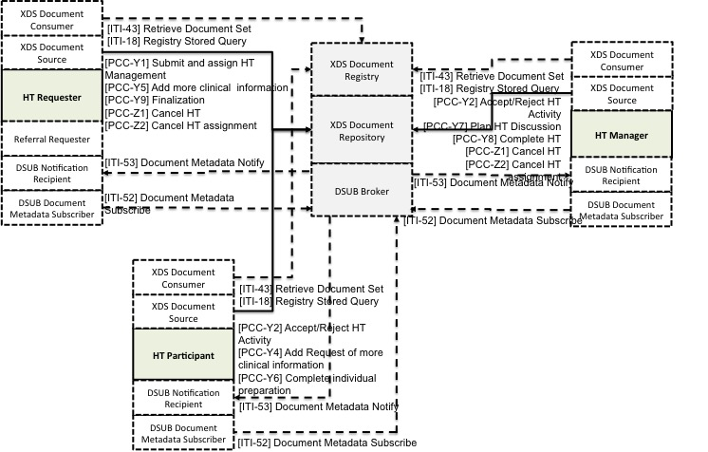

Figure X.1-1: XCHT-WD Actor/Transaction Diagram

Figure X.1-1 shows only the actors and transactions involved in the creation, updating and sharing of Heart Team Workflow Document, in order to allow a better readability of the figure. Transactions and actors involve in the creation and sharing of clinical documents, images, videos etc are not shown in this figure.

Table X.1-1 lists the transactions defined in this profile for each actor directly involved in the XCHT-WD Profile. To claim support of this Profile, an implementation of an actor must perform the required transactions (labeled “R”) and may support the optional transactions (labeled “O”). Actor groupings are further described in Section X.3.

Table X.1-1: XCHT-WD Profile - Actors and Transactions

| Actors | Transactions | Optionality | Section in Vol. 2 |
| --- | --- | --- | --- |
| HT Requester | [PCC-Y1] Submit and assign HT Management | R | PCC TF-2: 3.Y1 |
| [PCC-Y5] Add more clinical information | R | PCC TF-2: 3.Y5 |
| [PCC-Y9] Finalization | R | PCC TF-2: 3.Y9 |
| [PCC-Z1] Cancel HT | R | PCC TF-2: 3.Z1 |
| [PCC-Z2] Cancel HT assignment | R | PCC TF-2: 3.Z2 |
| HT Manager | [PCC-Y2] Accept/Reject HT Activity | R | PCC TF-2: 3.Y2 |
| [PCC-Y3] Assign HT Participation | R | PCC TF-2: 3.Y3 |
| [PCC-Y7] Plan HT Discussion | R | PCC TF-2: 3.Y7 |
| [PCC-Y8] Complete HT | R | PCC TF-2: 3.Y8 |
| [PCC-Z1] Cancel HT assignment | R | PCC TF-2: 3.Z1 |
| [PCC-Z2] Cancel HT | R | PCC TF-2: 3.Z2 |
| HT Participant | [PCC-Y2] Accept/Reject HT Activity | R | PCC TF-2: 3.Y2 |
| [PCC-Y4] Add Request of more clinical information | R | PCC TF-2: 3.Y4 |
| [PCC-Y6] Complete individual preparation | R | PCC TF-2: 3.Y6 |

### X.1.1 Actor Descriptions and Actor Profile Requirements

Normative requirements are typically documented in Volume 2 (Transactions) and Volume 3 (Content Modules). Some Integration Profiles, however, contain requirements which link transactions, data, and/or behavior. Those Profile requirements are documented in this section as normative requirements (“shall”).

#### X.1.1.1 Heart Team Requester

The Heart Team Requester (HT Requester) is responsible for initiating the workflow of the HT process.

The HT Requester is responsible for assigning a HT Manager to this workflow instance by invoking the “Assign HT Management” transaction.

The HT Requester is responsible for making available more clinical information (reports, images or eReferral workflow) to all HT members using the “Add results of more clinical information Transaction”.

The HT Requester is responsible for completing the workflow by receiving the Final Report, acknowledging the receipt of the report, and making available new clinical results, if requested, with the Finalization transaction. This transaction completes the workflow.

#### X.1.1.2 Heart Team Manager

The Heart Team Manager (or HT Manager) is responsible for accepting/refusing the management of HT received from the HT Requester by initiating the Accept/Reject HT Management transaction.

The HT Manager is responsible for assigning staff to the HT by initiating the “Assign HT Participation” transaction. The process of defining the list of participants is outside the scope of this profile.

The HT Manager is also responsible for planning the team’s communication, initiating the “Plan HT Discussion” transaction, and creating the Final Report as part of the “Perform HT evaluation” transaction.

#### X.1.1.3 Heart Team Participant

A Heart Team Participant (HT Participant) is responsible for accepting or refusing to participate in the HT initiating the “Accept/Reject HT” transaction and for requesting more information. Heart Team Participant is also responsible of providing individual evaluation reports, which will be needed in preparation for HT discussion.

## X.2 XCHT-WD Actor Options

None.

## X.3 XCHT-WD Required Actor Groupings

When a profile mandates that an Actor be grouped with another Actor(s), the mandated grouping requirement is defined in this section. The “grouped Actor”, specified as the second half of the pairing, may be from this profile or a different domain/profile. These mandatory groupings, plus pointers to further descriptions and content bindings, if necessary, are given in the table below.

An Actor from this profile (Column 1) must implement all of the required transactions and/or content modules in this profile ***in addition to*** all of the transactions required for the grouped actor (Column 2). If this is a content profile, and actors from this profile are grouped with actors from a workflow or transport profile, “content bindings” required by the transport profile may be defined to describe how data from the content module is mapped into data elements from the workflow or transport transactions.

In some cases, required groupings are defined as at least one of an enumerated set of possible actors; this is designated by merging column one into a single cell spanning multiple potential grouped actors. Notes are used to highlight this situation.

Section X.5 describes some optional groupings that may be of interest for security considerations and section X.6 describes some optional groupings in other related profiles.

The grouping of XDW actors with each of the XCHT-WD actors is specified in table X.3-1. These XDW actors support the creation, consumption and update of the XDW workflow document, which is the shared data structure, that tracks the evolution of the workflow. This allows the workflow definition actors at any point in the workflow to access the most current status of the workflow and share the tasks performed with all other workflow definition actors.

Note: See IHE ITI TF-1: Section 30.3 (XDW Supplement) for other groupings that are needed for the XDW Actors to permit sharing of a Workflow Document with IHE XDS, XDR or XDM Profiles.

XCHT-WD actors shall be grouped with DSUB actors to grant an interoperable system for task status update notification. The DSUB infrastructure is intended to provide specific notifications to the participants of the HT using a XDS.b environment with a XDW infrastructure for workflow sharing infrastructure.

Table X.3-1: XCHT-WD Required Actor Groupings

| XCHT-WD Actor | Actor to be grouped with | TF Volume and Section | Content Bindings Reference |
| --- | --- | --- | --- |
| HT Requester | XDW Content Creator | ITI TF-1: 30.1.1 | ITI TF-3:5 |
| XDW Content Updater | ITI TF-1: 30.1.3 | ITI TF-3:5 |
| XDW Content Consumer | ITI TF-1: 30.1.2 | ITI TF-3:5 |
| XDS Document Source | ITI TF-1: 10.1.1.1 | -- |
| XDS Document Consumer | ITI TF-1: 10.1.1.2 | -- |
| DSUB Document Metadata Subscriber | ITI TF-1: 26.1.1.2 | -- |
| DSUB Notification Recipient | ITI TF-1: 26.1.1.4 | -- |
| HT Manager | XDW Content Updater | ITI TF-1: 30.1.3 | ITI TF-3:5 |
| XDW Content Consumer | ITI TF-1: 30.1.2 | ITI TF-3:5 |
| XDS Document Source | ITI TF-1: 10.1.1.1 | -- |
| XDS document Consumer | ITI TF-1: 10.1.1.2 | -- |
| XDS-I Image Document Consumer | RAD TF-1: 18 | -- |
| DSUB Document Metadata Subscriber | ITI TF-1: 26.1.1.2 | -- |
| DSUB Notification Recipient | ITI TF-1: 26.1.1.4 | -- |
| HT Participant | XDW Content Updater | ITI TF-1: 30.1.3 | ITI TF-3:5 |
| XDW Content Consumer | ITI TF-1: 30.1.2 | ITI TF-3:5 |
| XDS Document Source | ITI TF-1: 10.1.1.1 | -- |
| XDS document Consumer | ITI TF-1: 10.1.1.2 | -- |
| DSUB Document Metadata Subscriber | ITI TF-1: 26.1.1.2 | -- |
| DSUB Notification Recipient | ITI TF-1: 26.1.1.4 | -- |
| XDS-I Image Document Consumer | RAD TF-1: 18 | -- |

**Note 1: The XCHT-WD actor defined in this profile, in order to receive notifications, SHALL be grouped with at least one of the this two actors: DSUB Notification Recipient , DSUB Notification Puller.**

The following sections identify how DSUB functionalities shall be used to notify workflow Status updates. Other additional uses of DSUB filters for subscriptions are not forbidden, however the following shall be considered implementation requirements for XCHT-WD actors.

## X.4 XCHT-WD Overview

In many countries, the high healthcare specialization is centralized in few hospitals in order to make limited health resources widely available, because they are often very expensive. For example, in the cardiac field, there are many community hospitals without cardiac surgical services. Community hospitals need remote support of many professionals that work in other organizations, in order to guarantee an optimal treatment strategy in a specific clinical situation such as stable CAD (Coronary Artery Disease), NSTEMI (non-ST elevation myocardial infarction), Cardiogenic Shock (CS), or aortic valve disease. Many countries are moving to create dynamic and multidisciplinary teams of professionals who are able to perform a complete analysis of the more complex clinical cases. The team is typically called a “Heart Team” (HT) in the cardiac arena. The HT is responsible for the management of the clinical pathway for patients with cardiac disease. However, it is difficult to manage and coordinate remote interaction among healthcare professionals involved in a Heart Team, that belong to different organizations and that use different software The aim of the HT is to facilitate appropriate decision making on the treatment or intervention used for patients. For this reason, a flexible common workflow is needed that define rules and activities of each system used by the HT members in the workflow of HT.

The XCHT-WD profile defines the workflow, intended as a common set of rules and activities, related to the collaboration of the members of a dynamic network of cardiovascular professionals that belong to different hospitals, called a Heart Team (HT), to facilitate appropriate decision making on the treatment or intervention used for patients and to better manage the knowledge exchange. This profile is based on the XDW profile.

**X.4.1 Concepts**

### X.4.1.1 Heart Team

The Heart Team (HT) is a dynamic network of professionals in the cardiovascular field. They can belong to different hospitals, and they aim to facilitate appropriate decision making on the treatment or intervention of patients and to better manage the knowledge exchange.

Examples of cardiovascular diseases that can require the input of the HT according to Class I recommendation as required by US and European professional organization guidelines are:

* complex coronary artery disease1, 2
* Severe valvular heart disease (Aortic and/or Mitral valve)3
* Other Cardiovascular diseases that can benefit from the discussion with a HT approach are:

- heart rhythm disorder (arrhythmia)

- Advanced or Chronic Heart Failure

- Cardiogenic Shock

Note 1: 2011 ACCF/AHA/SCAI Guideline for Percutaneous Coronary Intervention: a report of the American College of Cardiology Foundation/American Heart Association Task Force on Practice Guidelines and the Society for Cardiovascular Angiography and Interventions. Circulation. 2011;124:e574–e651.

Note 2: 2014 ESC/EACTS Guidelines on myocardial revascularization, The Task Force on Myocardial Revascularization of the European Society of Cardiology (ESC) and the European Association for Cardio-Thoracic Surgery (EACTS) Developed with the special contribution of the European Association of Percutaneous Cardiovascular Interventions (EAPCI). Eur Heart J. 2014 Oct 1;35(37):2541-619.

Note 3: Nishimura RA, Otto CM, Bonow RO, et al. 2014 AHA/ACC guideline for the management of patients with valvular heart disease: executive summary: a report of the American College of Cardiology/American Heart Association Task Force on Practice Guidelines. J Am Coll Cardiol 2014;63:2438–88. *Vahanian A, Alfieri O, Andreotti F, et al. Guidelines on the management of valvular heart disease (version 2012): the Joint Task Force on the Management of Valvular Heart Disease of the European Society of Cardiology (ESC) and the European Association for Cardio-Thoracic Surgery (EACTS). Eur J Cardiothorac Surg 2012; 42:S1–44.

#### X.4.1.2 HT Documents

In this section we present the documents involved in the HT workflow.

The HT workflow specifies the usage of document types in the table below:

|  |  |
| --- | --- |
| Document Types | Definition |
| **Workflow Document** | A document that contains a list of tasks that each actor carries out or assign to other actors, the owner of task, the list of documents that task needs in input and in output (in italic in this table), and other information related to the task. This document has to be read by systems which translates contained workflow document in activities. The content of the below documents is outside the scope of this profile. |
| ***HT Request Document*** | A document that contains the reason for creating a HT to discuss a clinical case. It can also contain clinical data on the state of patient. This document is required in order to start the HT process. The content of this documents is outside the scope of this profile. |
| ***Image Manifest*** | A document identifying the image set subject of the HT Request |
| ***Image Set*** | Clinical images referenced in the Image Manifest. |
| ***Clinical Documents*** | A Clinical Document is useful to make decision on the clinical case. These may include the original Referral, supporting Laboratory Reports, Image Manifests and reports of prior imaging studies. The content of this documents is outside the scope of this profile. |
| ***Request for more information document*** | A document that contains the list of information (for example results of exams, visits etc) that HT participant suggests to provide to HT to make decision. The content of this documents is outside the scope of this profile. |
| ***eReferral Workflow Document*** | A workflow document related to requested exams or visits in order to response to “Request for more information document”. The content of this documents is outside the scope of this profile. |
| ***Individual evaluation report*** | An individual evaluation report is the document that contains the individual evaluation by an HT Participant on the clinical case based on the available clinical documents and images, before the common discussion and before making a decision by manager. Each HT participant may produce a Individual evaluation report. The content of this documents is outside the scope of this profile. |
| ***Final Report*** | A Final report is the document that contain the decision of the HT and the list of exams required for the further treatment of the patient. The content of this documents is outside the scope of this profile. |

**X.4.1.3 XDW Workflow Definition Profile representation**

When a cardiologist from a Community Hospital decides that additional support to care for a patient is necessary, assistance from the HT will be requested. The HT is composed of professionals selected based on the specific clinical need of the case, including the originating cardiologist. This workflow profile will define how the HT manager is assigned to the HT, how team members will be assigned, and how the members communicate. The HT will analyse all the information that the originating physician has provided, and may require new exams/tests before a final decision is made. Each HT member will provide a individual evaluation report. The HT may discuss the clinical case through a videoconference or through an exchange of text. The HT involvement concludes with a final report, containing the collective findings, conclusions and recommendations for further treatment or intervention of the patient. Supportive clinical documentation is included with this final decision.

This profile is built upon the ITI XDW Profile to manage the Cardiovascular Heart Team Workflow. XDS/XDS-I is the default underlying Document and Image Sharing Infrastructure. The Document Metadata Subscription (DSUB) profile provides the workflow and document availability notification infrastructure.

The Cross-Enterprise Cardiovascular HT modeled workflow tasks are represented in figure X.4.1.4-1 and are explained below.

1. HT Request Task: The HT Requester, usually this is the patient’s cardiologist that requests the involvement of the HT to discuss the clinical case, initiates the formation of the HT and provides existing case information. The HT Requester registers in the workflow document the creation and sharing of the HT Request Document (which includes all useful clinical documents or images as attachments or links) with the HT Manager.
2. HT Lead Task: An HT Manager (where a user can be a Cardiac Surgeon) can accept or reject the assignment as manager of the HT and therefore take charge of the HT Request. Accepting or rejection of this assignment is notified to the HT Request. This task can be repeated until a HT Manager accepts assignment for managing the HT Request.
3. HT Involvement Task: The HT Manager invites some HT Participants (for example another Cardiac Surgeon, or/and an Interventional Cardiologist involved in the treatment of the patient) to participate in the HT. The HT Participants can accept or reject the invitation by sending a notification to the HT Manager. When the HT Participant accepts the invitation, it can order new exams and request new information useful for decision making to be available for the HT Requester. Notifications of requests for new exams are delivered to the HT Requester. All individual evaluation reports may be provided by each HT Participant. The HT Manager will be notified when each of these reports becomes available. The workflow document contains an HT Involvement Task for each HT Participant invited.
4. HT Preparation Task: The HT Requester ensures the additional needed exams, tests, and information requested by the HT Participants are performed and provided to the HT through an eReferral workflow document. The workflow document contains an HT Preparation Task for each exam requested by the HT Participant.
5. HT Perform Task: The HT Manager can plan a videoconference with the HT Participants and the HT Requester so a common decision on the treatment of patient can be made, and the HT Requester and the HT Participants are notified. The output of this task is a final report that contains the HT treatment decision and potential orders for exams/tests needed for the treatment (for example, a diagnostic cath lab might be needed in order to prepare operational room). The HT Requester and HT Participants are notified.
6. Finalization Task: the HT Requester retrieves the final report, and if need, it provides the results of exams required in the final report through an eReferral workflow document. The HT Manager and the HT Participants are notified for the availability of exams and the conclusion of HT.

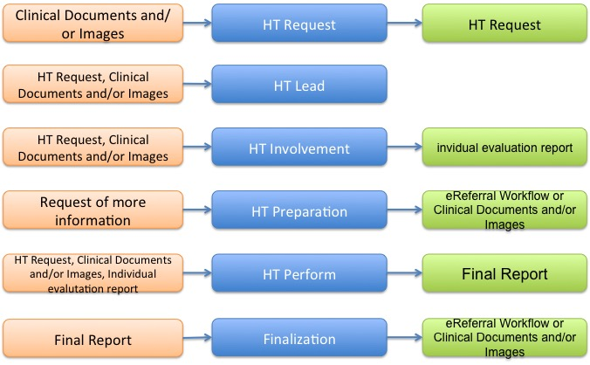

Figure X.4.1.3-1: Workflow Tasks for the Heart Team process

The XCHT-WD process flow, including the task states/status is shown in Figure X.4.1.4-2.

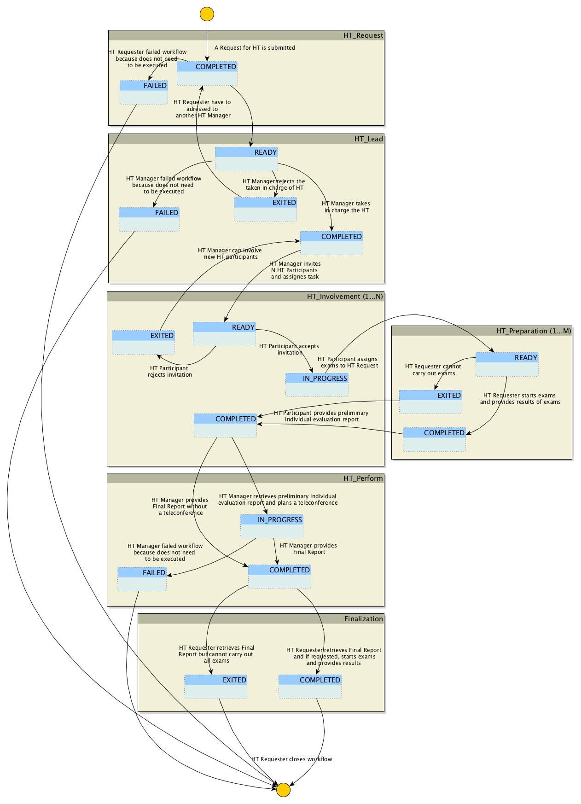

Figure X.4.1.3-2: Cross-Enterprise Cardiovascular HT Workflow Definition complete process flow

The following table X.4.1.4-1 lists the various documents that shall, conditionally, or may be referenced as either input or output documents for each task/status pair defined by the XCHT-WD.

The values used in the Option column are defined as follows:

**R:** Required. Compliant source systems shall provide the document as referenced.

**RE**: Required if present.

**C:** Conditional. Compliant source systems shall provide the document referenced if the document is available.

**O:** Optional. Compliant source systems may choose to provide the document reference.

**N/A:** Not Applicable.

|  |  |  |  |  |  |  |
| --- | --- | --- | --- | --- | --- | --- |
| **Task** | **Workflow Participant** | **Task Status** | **Input docs** | **Option** | **Output docs** | **Option** |
| HT_Request [1..1] | HT Requester | COMPLETED | Clinical Documents and images | R | HT Request | R |
| FAILED | N/A | - | N/A | - |
| HT_Lead [1..*] | HT Manager | READY | Clinical Documents and images | R | N/A | - |
| HT Request | R |
| COMPLETED | N/A | - | N/A | - |
| EXITED | N/A | - | N/A | - |
| FAILED | N/A | - | N/A | - |
| HT_Involvement [1..*] | HT Participant | READY | Clinical Documents and images | R | N/A | - |
| HT Request | R |
| IN_PROGRESS | N/A | - | N/A | - |
| COMPLETED | eReferral Workflow Document | C if there is HT_preparation=COMPLETED | Individual evaluation report | O |
| EXITED | N/A | - | N/A | - |
| HT_Preparation [0…*] | HT Requester | READY | Request of more infomration | R | N/A | - |
| COMPLETED | N/A | - | eReferral Workflow Document or Clinical documents/ Images | R |
| EXITED | N/A | - | N/A | - |
| HT_Perform [1..1]) | HT Manager | IN_PROGRESS | Clinical Documents and Images | R | N/A | - |
| HT Request | R |
| eReferral Workflow Document or Clinical documents/ Images | C if there is HT_preparation=COMPLETED |
| Individual evaluation report | R |
| COMPLETED | N/A | - | Final Report | R |
| FAILED | N/A | - | N/A | - |
| Finalization (1…1) | HT Requester | COMPLETED | Final Report | R | eReferral Workflow Document or Clinical documents/images | RE |
| EXITED | N/A | - | N/A | - |

Table X.4.1.3-1: Tasks/Documents related to the Cross-Enterprise Cardiovascular HT process

The Workflow Actors involved in the XCHT-WD process are shown with the workflow task/status transactions in Figure X.4.1.4-3.

A Workflow Participant Actor is an abstraction of system along with users involved in the XCHT process. They can be identified based on their roles in the process as one of four specific IHE Actors. Each of these workflow participants has specific rights and duties in the process. They drive the process from one step to another, performing determinate actions on the workflow.

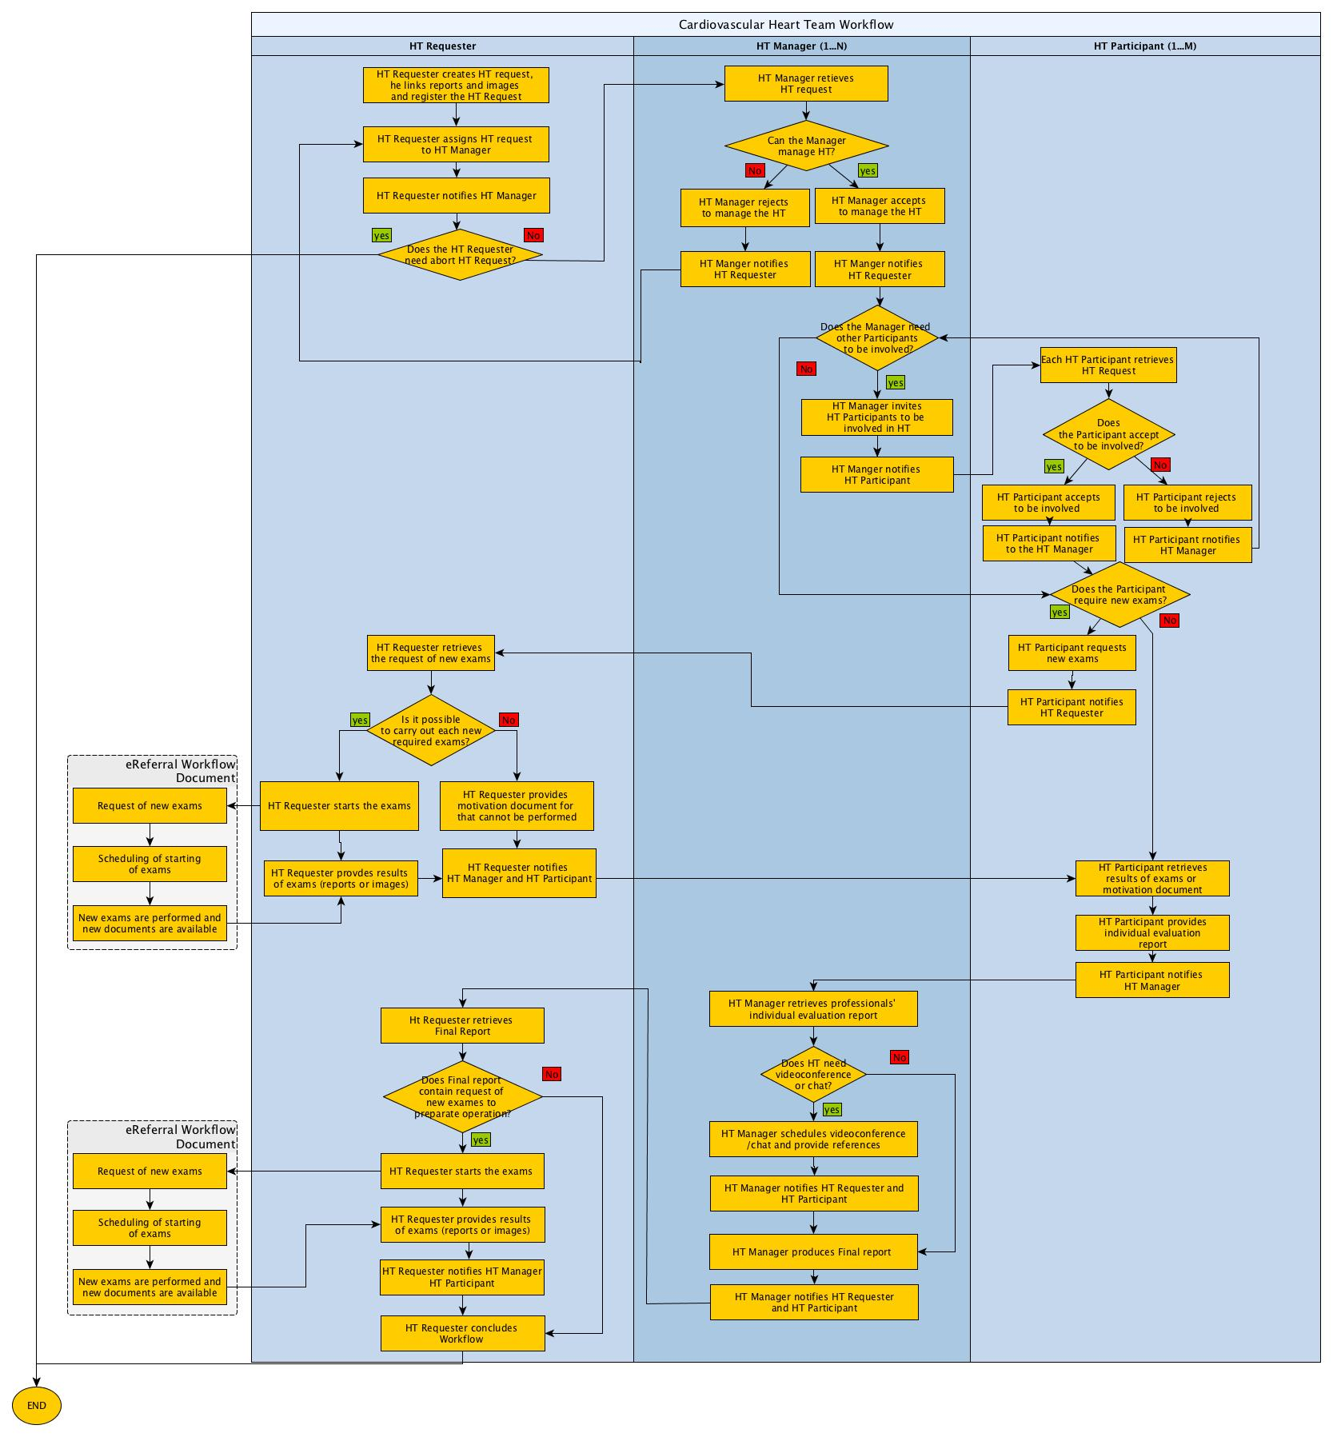

Figure X.4.1.3-3: XCHT-WD Actor Workflow Transitions Diagram

#### X.4.1.4 Delivery of Notifications

XCHT-WD actors are grouped with actors in the DSUB profile to enable sending notifications about workflow status updates.

The following sections identify how DSUB subscriptions should be used in the context of the Heart Team workflow by actors involved in the XCHT-WD profile. Other uses of DSUB filters for subscriptions are not forbidden.

#### X.4.1.4.1 Workflow Status Update Notification for the HT Requester

Once a Heart Team Workflow is submitted, the HT Requester may require progress notifications on the workflow.

The HT Requester would create a related subscription that identifies the specific Workflow Instance Id as a filter parameter for the creation of notifications for the patient just submitted. This subscription shall be submitted via transaction [ITI-52] Document Metadata Subscribe characterized by the following parameters:

* *TerminationTime =* unspecified. This allows to create a subscription without an expiration date/time;
* *topics* = “ihe:FullDocumentEntry”. This allows receiving notifications that convey the full documentEntry metadata related to the Workflow Document published.
* *Subscription Filter* = “urn:uuid:aa2332d0-f8fe-11e0-be50-0800200c9a66” (Subscriptions for DocumentEntry metadata). This allows to subscribe for documents published with specific metadata.
* *$XDSDocumentEntryReferenceIdList filter* = workflow Instance Id.

From this time, any update to the workflow document is notified to the HT Requester.

#### X.4.1.4.3 HT Lead Workflow Task Assignment Notification

The HT Requester assigns the management of HT to HT Manager. The Workflow Document updated by the HT Requester is published identifying the HT Manager as intended recipient for the submission (using the intendedRecipient submissionSet metadata). The HT Manager shall create a subscription characterized by the following parameters.

* *TerminationTime =* unspecified. This allows to create a subscription without an expiration date/time;
* *topics* = “ihe:SubmissionSetMetadata”. This allows receiving notifications that convey the submissionSet metadata, related to a submission of documents targeted to the HT Manager itself.
* *Subscription Filter* = “urn:uuid:868cad3d-ec09-4565-b66c-1be10d034399” (Patient-Independent Subscriptions for SubmissionSet metadata). This allows subscribing for submissions intended to a specific recipient.
* *$XDSDocumentEntryReferenceIdList filter* = workflow Instance Id.

From this time forward, any update of the workflow document notifies the HT Manager.

#### X.4.1.4.3 Workflow Status Update Notification for the HT Manager

Once a HT Manager accept to manage, the HT may require progress notifications on the workflow.

The HT Manager would create a related subscription that identifies the specific Workflow Instance Id as a filter parameter for the creation of notifications for the patient just submitted. This subscription shall be submitted via transaction [ITI-52] Document Metadata Subscribe characterized by the following parameters:

* *TerminationTime =* unspecified. This allows to create a subscription without an expiration date/time;
* *topics* = “ihe:FullDocumentEntry”. This allows receiving notifications that convey the full documentEntry metadata related to the Workflow Document published.
* *Subscription Filter* = “urn:uuid:aa2332d0-f8fe-11e0-be50-0800200c9a66” (Subscriptions for DocumentEntry metadata). This allows to subscribe for documents published with specific metadata.
* *$XDSDocumentEntryReferenceIdList filter* = workflow Instance Id.

From this time forward, any update of the workflow document notifies the HT Manager.

#### X.4.1.4.4 HT Involvement Workflow Task Assignment Notification

The HT Manager assigns the performance of HT to HT Participant. The Workflow Document updated by the HT Manager is published identifying the HT Participant as intended recipient for the submission (using the intendedRecipient submissionSet metadata). The HT Participant, once configured, shall create a subscription characterized by the following parameters.

* *TerminationTime =* unspecified. This allows to create a subscription without an expiration date/time;
* *topics* = “ihe:SubmissionSetMetadata”. This allows receiving notifications that convey the submissionSet metadata, related to a submission of documents targeted to the HT Participant itself.
* *Subscription Filter* = “urn:uuid:868cad3d-ec09-4565-b66c-1be10d034399” (Patient-Independent Subscriptions for SubmissionSet metadata). This allows subscribing for submissions intended to a specific recipient.
* *$XDSSubmissionSetIntendedRecipient* = the HT Participant actor. It is out of scope for this profile to define how to identify the HT Participant. This should be defined by local policies and by Affinity Domain configurations.

The HT Participant is notified when a HT Manager identifies the Participant to HT as intended recipient in the submission of the HT Workflow Document. The HT Participant integrates this request to its local workflow process.

#### X.4.1.4.5 Workflow Status Update Notification for the HT Participant

Once a HT Participant accept to be involved in the HT, there may be a require progress notifications on the workflow.

The HT Participant would create a related subscription that identifies the specific Workflow Instance Id as a filter parameter for the creation of notifications for the patient just submitted. This subscription shall be submitted via transaction [ITI-52] Document Metadata Subscribe characterized by the following parameters:

* *TerminationTime =* unspecified. This allows to create a subscription without an expiration date/time;
* *topics* = “ihe:FullDocumentEntry”. This allows receiving notifications that convey the full documentEntry metadata related to the Workflow Document published.
* *Subscription Filter* = “urn:uuid:aa2332d0-f8fe-11e0-be50-0800200c9a66” (Subscriptions for DocumentEntry metadata). This allows subscription for documents published with specific metadata.
* *$XDSDocumentEntryReferenceIdList filter* = workflow Instance Id.

From this point forward, any update to the workflow document notifies the HT Participant.

### X.4.2 Use Cases

Two completed use cases on HT collaboration are described in this profile. The first is based on a basic HT composed by the requester of support, an interventional cardiologist, and the clinician that can provide support and manage the HT. The second use case is related to a HT composed of the requester of support and many professionals. This is a complex cardiovascular clinical case. This complex use case also describes rejection of involvement in the HT by manager or participants.

This section also contains two exceptions. The first exception describes the cancellation of the process by the requester or manager. The second exception describes the invitation rejection by the requester to manage the HT, or the invitation rejection of the manager to participate in the HT.

In each use cases and exceptions, professionals perform the following roles:

* requester of support by HT for choosing the best treatment strategy for the patient; the use of a system that supports the HT Requester actor
* manager of the HT that support the requester; the use of a system that support the HT Manager and HT Participant actors
* participants of the HT that collaborates with each other; the use of a system that support the HT Participant actor

#### X.4.2.1 Use Case #1: Basic Heart Team Coordination

The following Use Case illustrates the workflow of management of the Cross-enterprise Cardiovascular Heart Team. This HT is composed only of requester and manager of HT without involvement of other professionals. The use case is similar to a tele-consultation, when the requester and manager collaborate with each other through many interaction points such as sharing of documents (reports, results of exams, videos and images) and/or video/teleconference.

In this use case, the requester, Dr. Brown, an interventional cardiologist authorized to perform PCI, needs support from the HT to decide how to treat a patient with complex coronary disease (PCI or CABG intervention) avoiding any unnecessary patient transfers to cardiac surgery department. He involves Dr. Johnson, a cardiac surgeon, in order to manage the HT. The HT is composed of the requester, Dr. Brown, and the manager of HT, Dr. Johnson. Other professionals are not included in this workflow.

During the workflow, HT shares several clinical data provided by requester, some of which are required by the manager to have a more complete context of the case. Clinical documentation allows the manager to provide a Individual Evaluation Report which is shared with HT. The Individual Evaluation Report will be consolidated in a Final Report after a videoconference among requester and manager is completed. The Final Report contains the decision of *a CABG* intervention for the patient and the request of new exams in order to prepare the intervention before the arrival of the patient for the procedure. The workflow is completed when the requester provides exams results that were requested by the manager.

In this use case, Dr. Brown uses a system supported by HT Requester Actor, and Dr. Johnson uses a system supported by HT Manager and HT Participant. The workflow document manages this process and contains links to all documents shared in this use case (HT Request Document, request for new exams, clinical document or report or images, Individual Evaluation Report and Final Report).

##### X.4.2.1.1 Basic Heart Team Coordination Use Case Description

1. **Request start-up of HT**

On Wednesday morning, Dr. Brown, an interventional cardiologist, examines a 67-year-old male patient, diagnosed with hypertension without a previous history of cardiac disease. The patient presents with signs and symptoms of effort angina, CCS class III. The patient undergoes an echocardiogram to evaluate cardiac function. The systolic function of the left ventricle is normal with an ejection fraction of 60%. Dr. Brown decides to evaluate the patient with a coronary angiography which reveals a critical (90%) stenosis at the ostium of the left anterior descending (LAD) and left circumflex (LCX) coronary arteries, and diffuse disease of the right coronary artery (RCA). SYNTAX score is 20. Class I recommendation in management of patients with complex coronary disease as issued in guidelines by American and European professional organizations require that patients with a multi-vessels stenosis and with SYNTAX score ≤22 be discussed in a HT.

Dr. Brown requests the involvement of the HT in order to decide on the plan and treatment of the patient. Dr. Brown selects the data to share with the HT, and Dr. Brown’s secretary prepares the HT Request to activate the HT through his software. Through IT infrastructure (supported by XDS, DSUB, and XDW profiles) and on the basis of local policies, the HT Request is available for a cardiac surgeon. The HT Request links the following documents and images: Medical history, Drug therapy, Biochemical profile test blood, Euroscore II and Syntax score, ECG (Image), echocardiogram, Angiography and ventriculography (Cine-loops).

The new workflow document for this case is automatically created when the HT Request is created, and this document is shared with recipient through the same IT infrastructure. Subsequent activity will update this document. This document is a technical document that is not viewable via the UI to the end user.

**B. Definition of Manager of HT**

The cardiac surgeon (Dr. Johnson) software, which is subscribed to receive notifications addressed to itself, receives the notification about the availability of an HT Request for itself using the IT infrastructure, in particular thank to DSUB Profile (ITI-53). Dr. Johnson’s software retrieves documents and images linked to the HT Request and it allows Dr. Johnson to review the clinical case. Dr Johnson decides that he is able to manage the HT request. Dr. Johnson accepts the request electronically which makes Dr. Johnson in charge of the management of the HT for this clinical case. Dr. Brown is electronically notified of Dr. Johnson’s acceptance of the HT Request.

The Dr. Johnson software automatically updates the workflow document by marking the document indicating he is in charge of HT Request.

**C. Involvement of participants to HT**

Dr Johnson considers how to staff the HT and determines that only he and Dr. Brown are needed. Dr. Johnson decides that the staffing of the HT is complete and no any other professionals will be included.

To appropriately treat the patient, Dr. Johnson decides that a new echocardiogram (Cine-loops) is needed. Electronically, Dr. Johnson completes the request for a new echocardiogram which is electronically sent to Dr. Brown.

Dr. Johnson system automatically updates the workflow document indicating that there aren’t other invited professionals and a request of new exams is required for Dr. Brown to perform.

**D. Filling additional requirements of the HT**

Dr. Brown performs a new echocardiogram (Cine-loops).

When the new echocardiogram results are electronically available, Dr. Johnson is electronically notified and his system can retrieve the documents through an IT infrastructure.

Dr. Brown system automatically updates the workflow document with indications that results of new exams are now available.

**E. Providing of a individual evaluation report**

Dr. Johnson software retrieves all clinical documents and images, and Dr. Johnson creates a individual evaluation report. Dr. Johnson software shares this document with HT members through an IT infrastructure.

Dr. Johnson software automatically updates the workflow document, indicating that individual evaluation report is now available.

**F. HT Decision**

1. Dr. Johnson decides it is better to speak with Dr. Brown through a videoconference. Dr. Johnson secretary uses the software to request a virtual meeting for next Monday at 10:00 am. Dr. Brown is electronically notified of the meeting. Dr. Johnson software automatically updates the workflow document, indicating that a videoconference is planned.
2. The HT meets via videoconference at 10:00 am on Monday. The HT reviews the clinical case and decides the best treatment path for the patient, which is a CABG which will be performed. Dr. Johnson creates a final report based on the HT discussion and conclusion. The final report contains the list of exams required by Dr. Johnson for the preparation of the following interventions: Hemogasanalysis and Echo-color Doppler (Cine-loops). Dr. Johnson’s software creates the final document and enable availability of the document for all HT members (Dr. Brown) and proper notification is sent to the members. Dr. Johnson software automatically updates the workflow document, indicating that a final report is now available.

**G. Finalization of needed documents for intervention or treatment**

1. Based on the final report, Dr. Brown performs the Hemogasanalysis and Echo-color Doppler (Cine-loops). Dr. Brown, using his software, shares the results of the exams with Dr. Johnson and confirms electronically that the workflow is completed. Dr. Brown’s software automatically updates the workflow document for the last time, indicating that the workflow is concluded by sharing the results of the exams that were requested during the videoconference.
2. Dr. Johnson is electronically notified when the results are available and he retrieves the results.

##### X.4.2.1.2 Basic Heart Team Coordination Process Flow

The following diagrams show sequence of transactions and sequence of tasks within the workflow describing the typical process flow for the Common Workflow scenario. Please see Appendix C for other use case flow chart diagram.

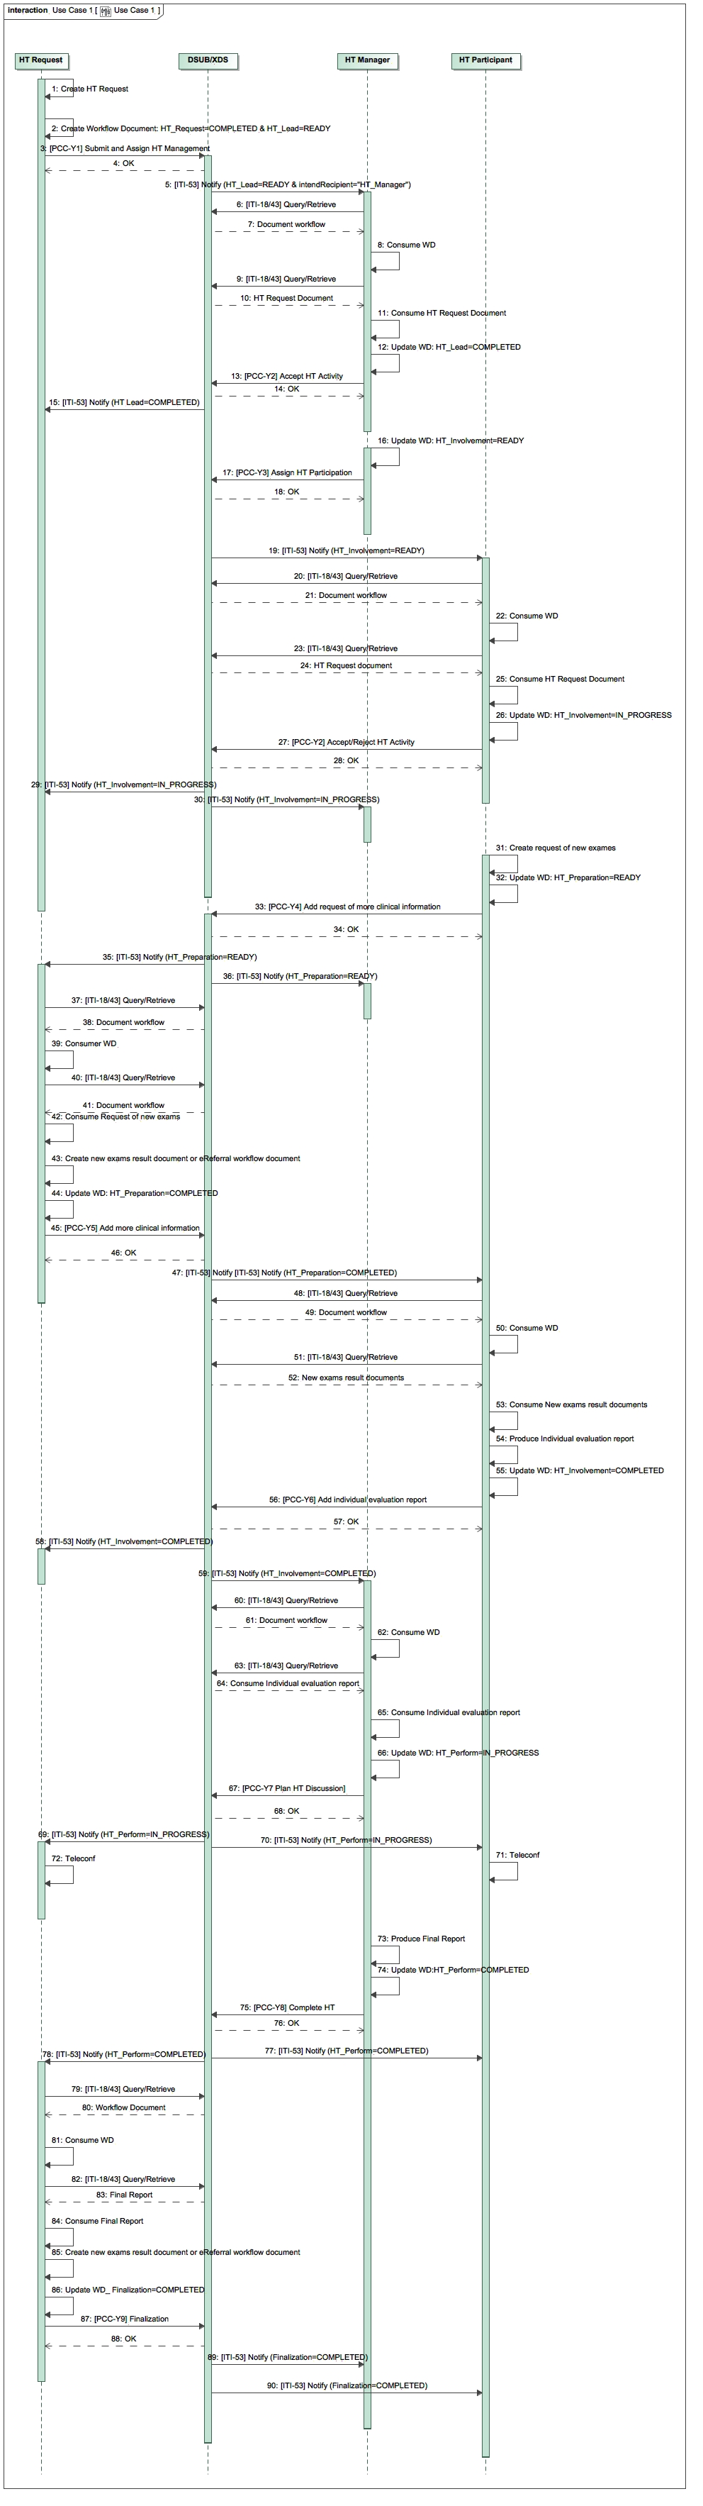



Figure X.4.2.1.2-1: XCHT-WD Sequence Diagram for use case 1

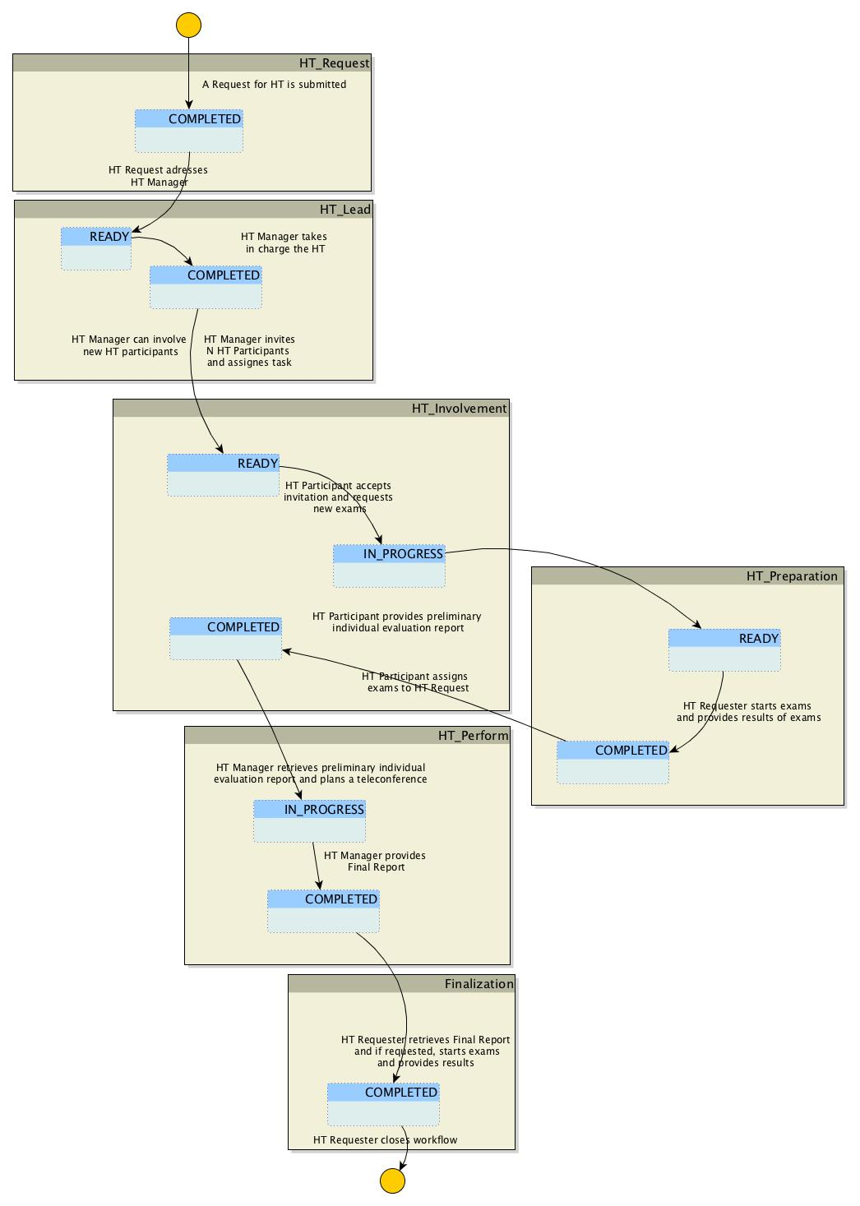

Figure X.4.2.1.2-2: XCHT-WD Process Flow for use case 1

#### X.4.2.2 Use Case #2: Complex Heart Team Coordination

The following use case illustrates the workflow management of a Cross-enterprise Cardiovascular Heart Team that is composed of other professionals besides the requester and manager of Heart Team. This use case describes the management of rejection the HT and the assignment to another manager. It describes also a reject of to be involved to HT as participant.

In this use case, the requester is a cardiologist, Dr. Smith, requests support from a cardiac surgeon, Dr. Johnson, to decide the best treatment path for the patient *with complex coronary disease* (PCI or CABG intervention) avoiding any unnecessary patient transfers to cardiac surgery or cathlab. Dr. Johnson rejects the assignment because he is unable to manage this HT case, due to complexities, and decides that HT is better suited for the job. Dr. Smith requests support from another cardiac surgeon, Dr. John, who works in another hospital. Dr. John accepts the request and invites interventional cardiologist, Dr. Brown, and a cardiothoracic anesthesiologist, Dr. Ralph, to HT but only Dr. Brown accepts the request to be involved. Consequently, the HT is composed of Dr. Smith, the cardiologist that is in charge of the patient, the cardiac surgeon, Dr. John, and the interventional cardiologist, Dr. Brown. During the process, Dr. Brown needs additional clinical report and asks to Dr. Smith to provide it. When all clinical information are available, all members of HT (except the requester) provide Individual Evaluation Reports, and on basis of these, Dr. John provide Final Report for Dr. Smith, without the use of videoconference. The decision is made to treat patient with PCI intervention, in the cathlab.

In this use case, Dr. Smith uses a system supported by HT Requester Actor, and Dr. Johnson and Dr. John uses system supported by HT Manager and HT Participant, and Dr. Ralph and Dr. Brown use a system supported by HT Participant. The workflow document manages this process, and it contains links to all documents shared in this use case (HT Request Document, Request to new exams, Clinical document or report or images, Individual Evaluation Report and Final Report).

**X.4.2.2.1 Complex Heart Team Coordination Use Case Description**

**A. Request Start-up of HT**

On Wednesday morning, Dr. Smith, an interventional cardiologist in a general hospital, visits a 67-year-old male patient, diagnosed with hypertension without a previous history of cardiac disease, who starts complaining of effort angina, CCS class III. The patient undergoes a cardiac echocardiogram to evaluate heart functionality. The systolic function of the left ventricle was normal, with an ejection fraction of 60%. Dr. Smith decides to evaluate the patient with a coronary angiography on Friday which reveals a critical (90%) stenosis at the ostium of the left anterior descending (LAD) and left circumflex (LCX) coronary arteries, and diffuse disease of the right coronary artery (RCA). SYNTAX score is 20. Class I recommendation in management of patients with complex coronary disease as issued in guidelines by American and European professional organizations require that patients with a multi-vessels stenosis and with SYNTAX score ≤22 be discussed in a HT.

Dr. Smith decides to request the involvement of the HT in order to take decision on the treatment of the patient. Dr. Smith selects the data to share with HT, and Dr. Smith’s secretary prepares the HT Request required to activate the HT, through his software. Through IT infrastructure (supported by XDS, DSUB, and XDW profiles) and on the basis of local policies, the HT Request is electronically available for a cardiac surgery. The HT Request links the following documents and images: Medical history, Drug therapy, Biochemical profile test blood, Euroscore II and Syntax score, ECG (Image), echocardiogram, Angiography and ventriculography (Cine-loops). Dr. Smith selects also who to address the management of Heart Team (Department of Dr. Johnson, a cardiac surgeon).

The new workflow document for this case is automatically created when the HT Request is created, and this document is shared with recipient through the same IT infrastructure. Subsequent activity will update this document. This document is a procedural document that cannot be seen by user of the software.

**B. Definition of Manager of HT**

The software of cardiac surgeon, Dr. Johnson, which is subscribed to receive notifications addressed to itself, receives a notification on availability of an HT Request for itself, using the IT infrastructure, in particular thank to DSUB Profile (ITI-53). The software of Dr. Johnson retrieves documents and images, and it allows to Dr. Johnson to study the clinical case. Dr. Johnson decides that he is not able to manage this HT case, due to complexities, and decides that HT is better suited for the job. He confirms his decision through his software, which notify this decision to Dr. Smith.

Dr. Smith decides another cardiac surgeon to address the management of Heart Team, Dr. John, and he inserts this decision in his software. Electronically, the availability of HT Request is notified to software of Dr. John, another cardiac surgeon who belongs to another department or hospital.

Dr. John sees the software notification and the documentation related to HT Request, and confirms electronically that he has taken charge of the management of the HT for this clinical case. The software of Dr. John automatically updates the workflow document, marking the taking charge of HT Request. Dr. Smith is electronically notified of Dr. John’s acceptance of the HT Request.

**C. Involvement of HT participants**

Dr John considers how to staff the HT and determines that the HT will consist of the following members, Dr. Brown, the interventional cardiologist that carried out the previous coronary angiography, Dr. Ralph, a cardiothoracic anesthesiologist that works with Dr. John, and Dr. Smith. Dr. John’s software electronically invites all members defined to be involved in HT.

Dr. Ralph electronically rejects the invitation because can’t commit to HT. Dr. John decides the HT can function without Dr. Ralph. Other involved professionals electronically confirms their participation, also providing other needed data. In fact, to decide the appropriate treatment for the patient, Dr. Brown requires that a new echocardiogram (Cine-loops) is needed. Electronically, the software of Dr. Brown confirms his participation, links a request for a new echocardiogram, and electronically notifies Dr. Smith.

**D. Filling additional requirements of the HT**

1. Dr. Smith performs a new echocardiogram (Cine-loops).
2. When the new echocardiogram results are electronically available, the software of Dr. Smith automatically updates the workflow document, indicating that results of new exams are now available. Consequently, all member of HT are electronically notified and their software can retrieve the documents through an IT infrastructure.

**E. Providing of a individual evaluation report**

On the basis of all clinical documents and images shared until now, Dr. John and Dr. Brown each create a individual evaluation report. The software of Dr. John and Dr. Brown updates automatically the workflow document, marking that their individual evaluation reports are now available. All member are notified on availability of these documents.

**F. HT Decision**

Dr. John analyzes the individual evaluation report prepared by Dr. Brown. Dr. Brown’s recommendation and his are the same, which is to perform a PCI intervention. Dr. John decides that it isn’t necessary to start a videoconference since the treatment recommendations are the same.

Dr. John creates a final report recommending a PCI through his software. Additional exams are not necessary. The software of Dr. John automatically updates the workflow document, indicating that a final report is now available. Proper notification is sent to the members of HT.

**G. Finalization of needed documents for intervention or treatment**

The software of Dr. Smith retrieves the final report and Dr. Smith, on basis of content of the report, electronically closes the process. The software of Dr. Smith automatically updates the workflow document for the last time, marking that the workflow is concluded, and all members are notified.

##### X.4.2.2.2 Complex Heart Team Coordination Process Flow

The following diagrams show sequence of transactions and sequence of tasks within the workflow which describes the typical process flow for the Common Workflow scenario. Please see Appendix C for other use case flow chart diagram.

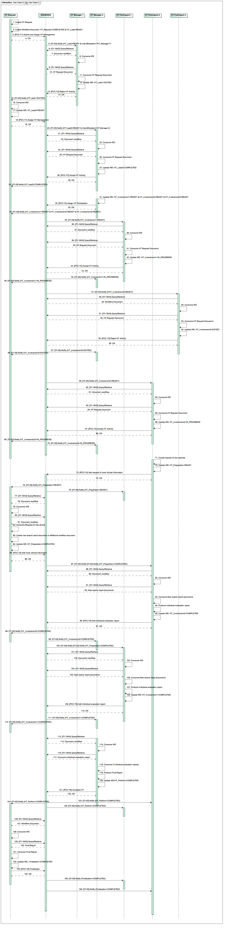

**

**

Figure X.4.2.2.2-1: XCHT-WD Sequence Diagram for Use Case 2

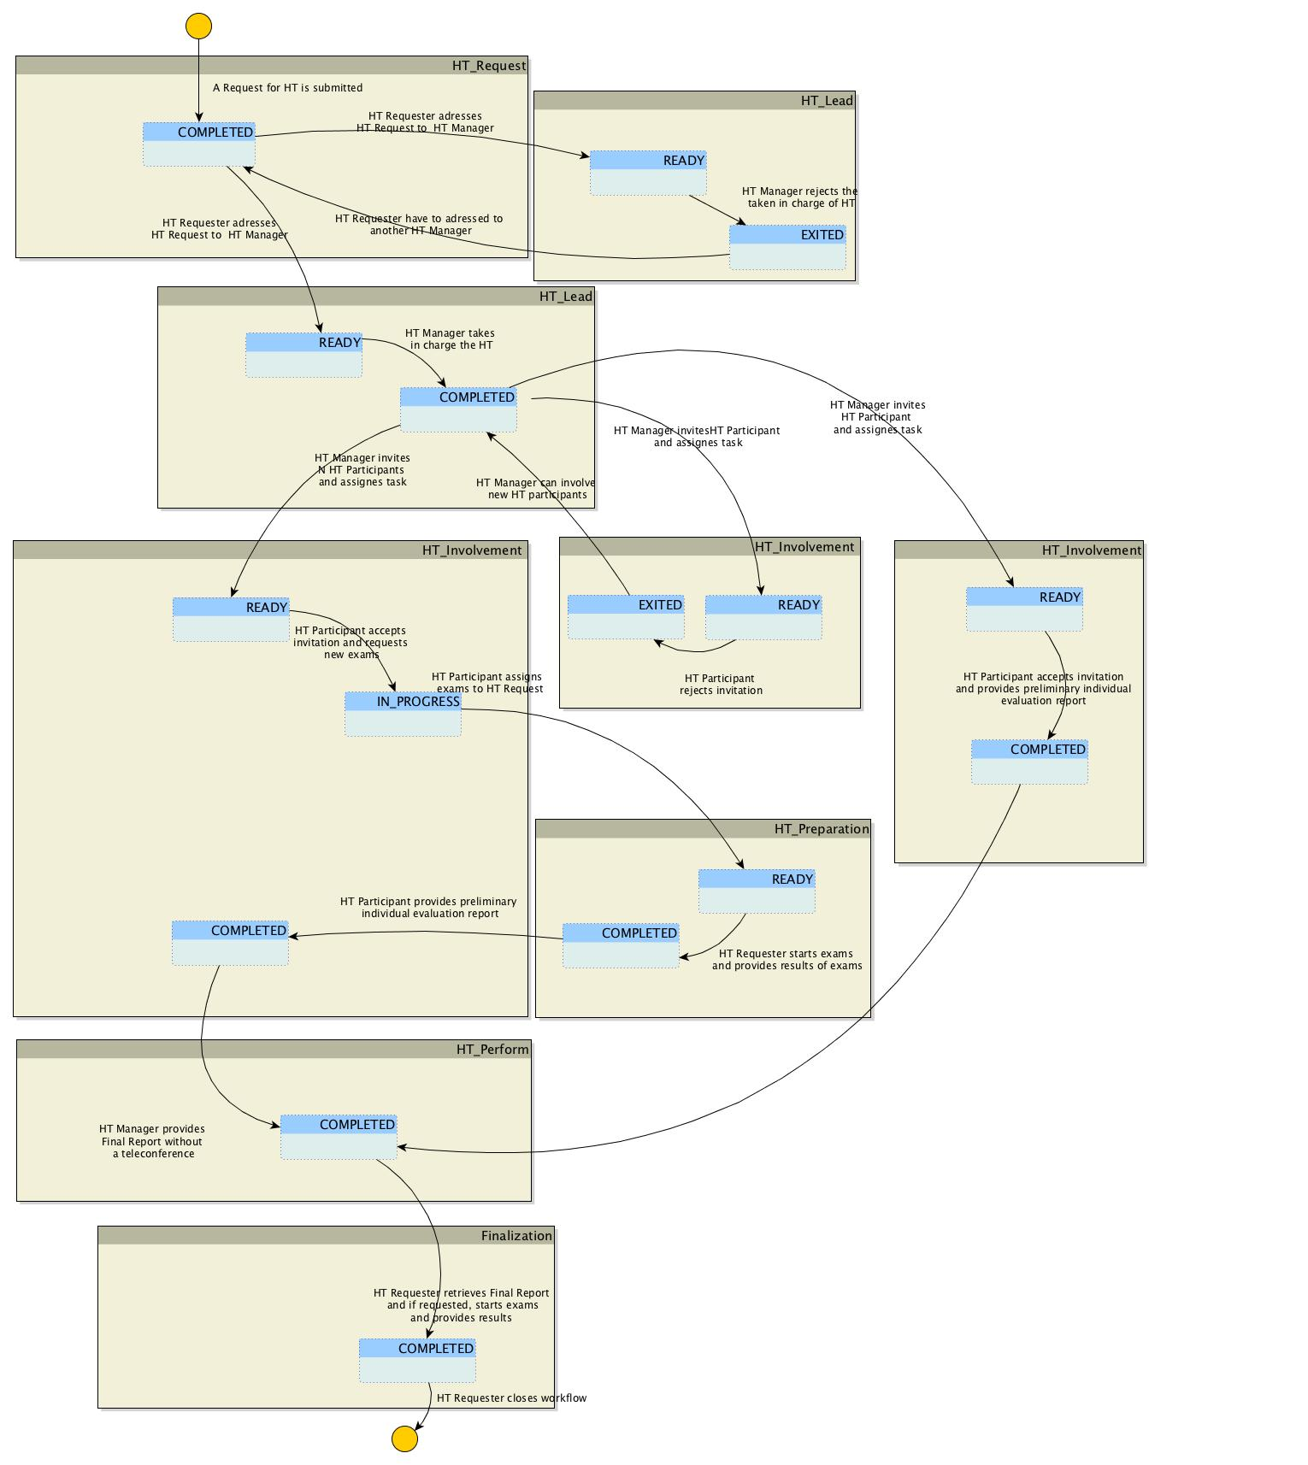Figure X.4.2.2.2-1: XCHT-WD Process Flow for Use Case 2

#### X.4.2.3 Exception #1: Heart Team Cancellation Scenario

The requester of support by HT wants to abort the process just created (case a) because the Request is no longer valid. This would occur if, the HT Request is incorrect or uncompleted or if the patient dies. Or, the manager of HT may want to abort the process (case b) because the case requires an emergency process or the patient dies.

**X.4.2.3.1 HT Cancellation Exception Description**

The HT Cancellation is the pathway scenario where a requesting facility has a need to cancel a request because the HT is no longer needed.

The HT Requester or HT Manager can want to abort the process. In the first case the HT Requester shall update the Workflow Document moving into status FAILED for the HT Request task and closing the workflow itself. In the second case, HT Manager shall update the Workflow Document moving into status FAILED for the HT lead or HT Perform task and closing the workflow itself.

This update notifies all the participants of the workflow. After the closure, a HT Workflow Document cannot be updated by any participant.

##### X.4.2.3.2 HT Cancellation Process Flow

The following diagram describes the typical process flow for the XCHT Workflow scenario when HT Requester fails the workflow (case a).

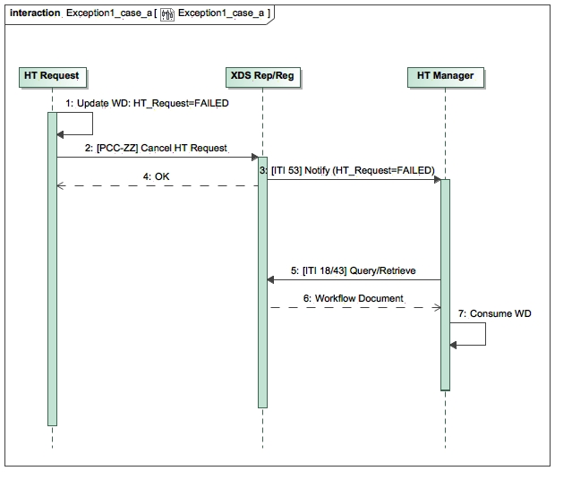

Figure X.4.2.3.2-1: XCHT-WD Sequence Diagram of actors for Exception 1 (case a)

The following diagram describes the typical process flow for the XCHT Workflow scenario when HT Manager fails the workflow (case b).

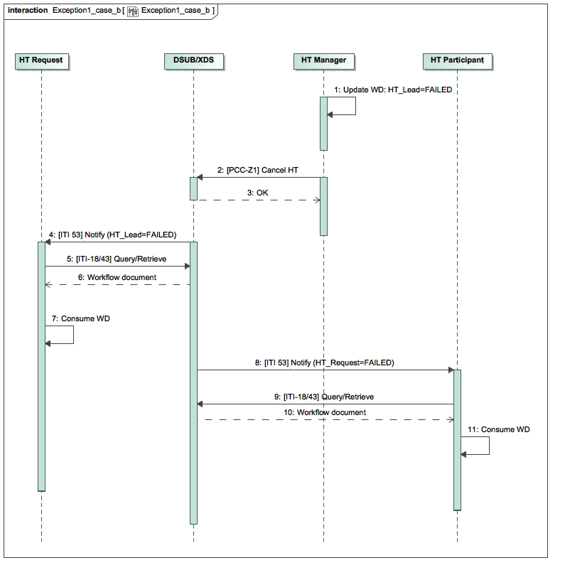

Figure X.4.2.3.2-2: XCHT-WD Sequence Diagram of actors for Exception 1 (case b)

#### X.4.2.4 Exception 2# Heart Team Assignment Cancellation

This use-case describe the scenario in which the requester of support by HT, for example Dr. Smith in use case 2, wants to revoke the assignment of HT request to invited manager of HT that has not already been claimed (case a) by Dr. Johnson in use case 2. Or, the manager of HT, Dr. John (in use case 2) wants to revoke the assignment of involvement in HT to an invited participant that has not already claimed (case b), such as Dr. Ralph in use case 2. These behaviors avoid blocking the process when HT Manager or HT Participant does not respond within a certain allotted time.

**X.4.2.4.1 HT Assignment Cancellation Exception description**

The HT Requester and HT Manager systems, are configured to revoke task assigned respectively to HT Manager and HT Participant systems that have not accomplish their activities within predefined working hours (E.g. the Community Hospital has network problems and after claiming the HT Manager could not respond). The HT Requester and HT Manager can revoke the assignment of the respectively HT Lead task and HT Involvement Task at any time before task completion. HT Requester and HT Manager actor can update respective HT Lead task and HT Involvement Task moving it into status EXITED.

The HT Requester actor could assign the management of HT to a new HT Manager actor if needed. The HT Manager actor could assign the management of HT to a new HT Participant actor if needed.

**X.4.2.4.2 HT Assignment Cancellation process-flow**

The following diagram describes the typical process flow for the XCHT Workflow scenario when HT Requester revoke HT Manager assignment (case a).

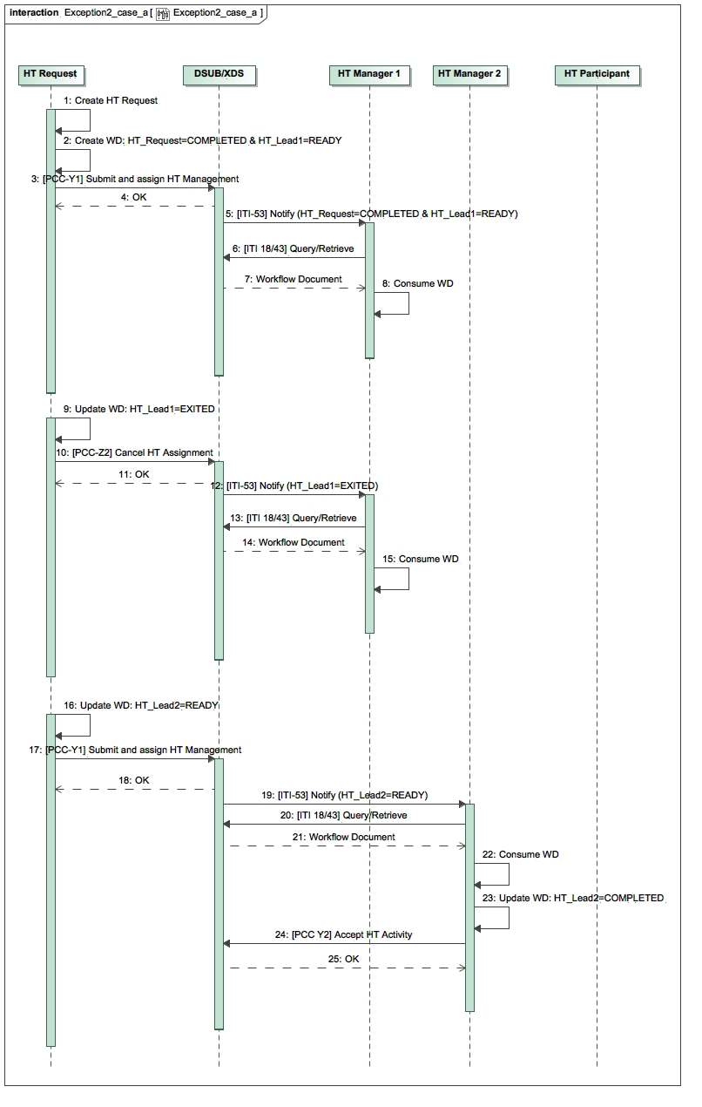

Figure X.4.2.4.2-1: XCHT-WD Sequence Diagram of actors for Exception 2 (case a)

The following diagram describes the typical process flow for the XCHT Workflow scenario when HT Manager revoke HT Participant assignment (case b).

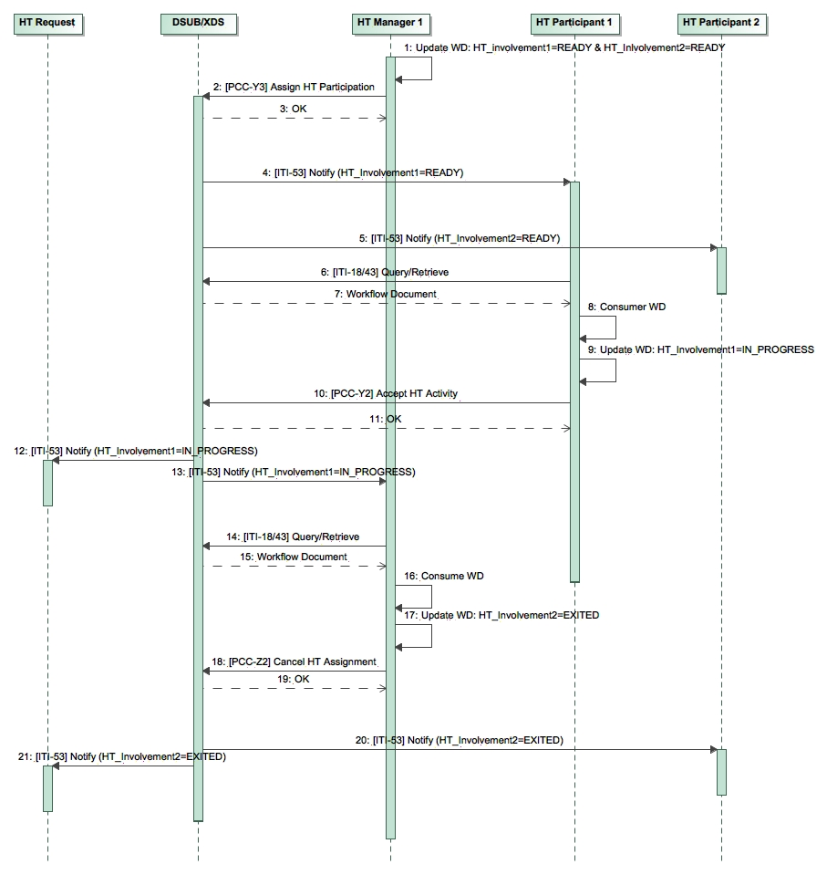

Figure X.4.2.4.2-2: XCHT-WD Sequence Diagram of actors for Exception 2 (case b)

## X.5 XCHT-WD Security Considerations

For this section please refer to the section ITI TF-1: 30.5 XDW Security Considerations

## X.6 XCHT-WD Cross Profile Considerations

In this section, some relationships of this profile are defined along with other profiles. These dependencies shall not be considered additional requirements for Actors involved in the Cross-Enterprise Cardiovascular Heart Team workflow.

Since the HT Manager and HT Participant could ask the HT Requester to execute new exams during the workflow, HT Requester can do it via eReferral Workflow document on basis of XBeR WD Profile and it can share this document with HT. For this reason, HT Requester should be supported by Referral Requester in order to start a separate workflow related to referral.

Appendices

1. Appendix A - Actor Summary Definitions

|  |  |
| --- | --- |
| **Actors** | **Description** |
| HT Requester | The actor is responsible for   * initiating the workflow of HT process for clinical support * assigning the management of HT to a HT Manager, * providing more clinical information, if requested, * completing the workflow by receiving the Final Report, and acknowledging the receiving of that report, providing also new clinical results |
| HT Manager | The actor is responsible for   * accepting/refusing the management of HT by HT Requester * staffing of HT * performing the HT, planning team’s communication, if requested, and creating Final Report |
| HT Participant | The actor is responsible for:   * accepting/refusing to participate to HT * providing request more clinical information, if needed * providing individual evaluation reports |

1. Appendix B - Transaction Summary Definitions

|  |  |
| --- | --- |
| **Transactions** | **Description** |
| [PCC-Y1] Submit and assign HT Management | HT Requester submits the workflow document and assigns the management of HT to HT Manager |
| [PCC-Y2] Accept/Reject HT Activity | HT Manager or HT Participant accepts or rejects to be involved to do activities expected for the actor. |
| [PCC-Y3] Assign HT Participation | HT Manager assigns activities expected for HT Participant |
| [PCC-Y4] Add Request of more clinical information | HT Participant requests that HT Requester provides more clinical information |
| [PCC-Y5] Add more clinical information | HT Requester provides more clinical information |
| [PCC-Y6] Complete individual preparation | HT Participant complete individual preparation and may provides an individual evaluation report |
| [PCC-Y7] Plan HT Discussion | HT Manager schedules the team’s communication |
| [PCC-Y8] Complete HT | HT Manager performs the HT request providing Final Report |
| [PCC-Y9] Finalization | HT Requester finalizes the Final Report providing new exams for preparation of operation for patient. |
| [PCC-Z1] Cancel HT | HT Requester or HT Manager forced workflow in failed status |
| [PCC-Z2] Cancel HT assignment | HT Requester or HT Manager revokes the assignment |

1. Appendix C – Adding use cases diagrams

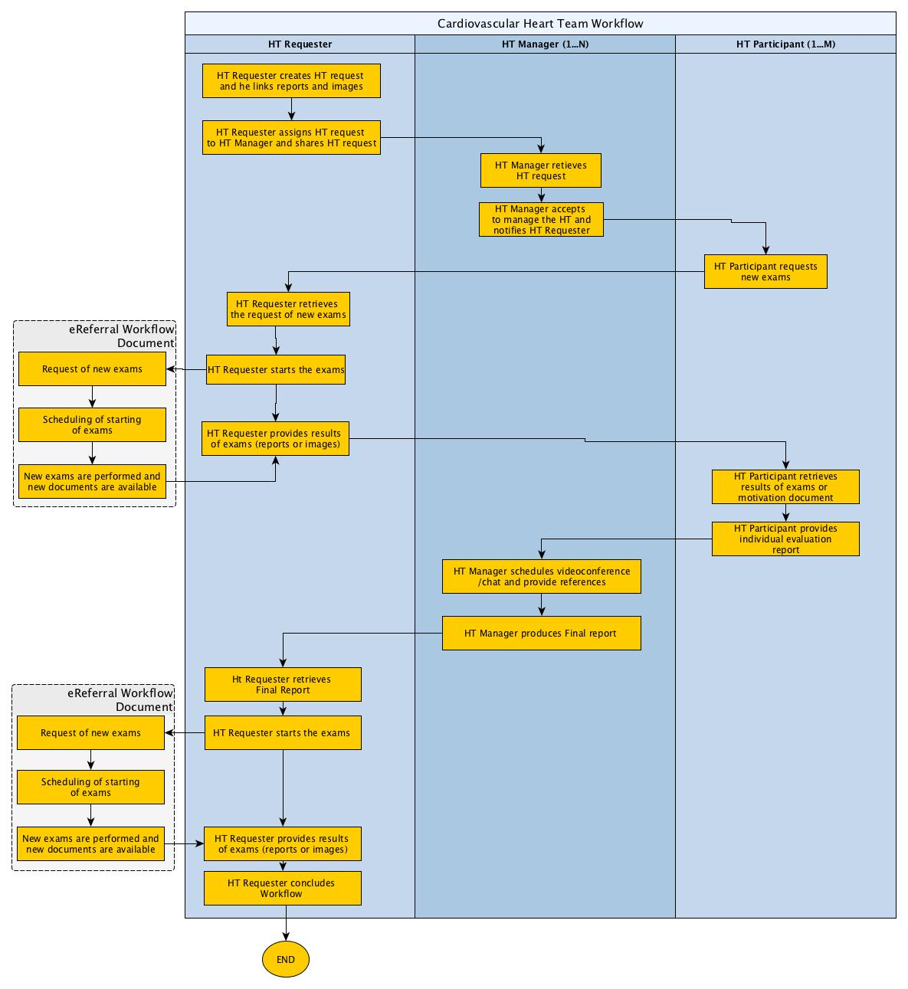

Figure Appendix C-1: XCHT-WD process flow of actors for use case 1 (section X.4.2.1): it illustrates the workflow of management of the Cross-enterprise Cardiovascular Heart Team for an HT composed only of requester and manager of HT without the involvement of other professionals. The use case is similar to a tele-consultation, when the requester and manager collaborate each other through many interaction points such as sharing of documents (reports, results of exams, videos and images) and/or video/teleconference.

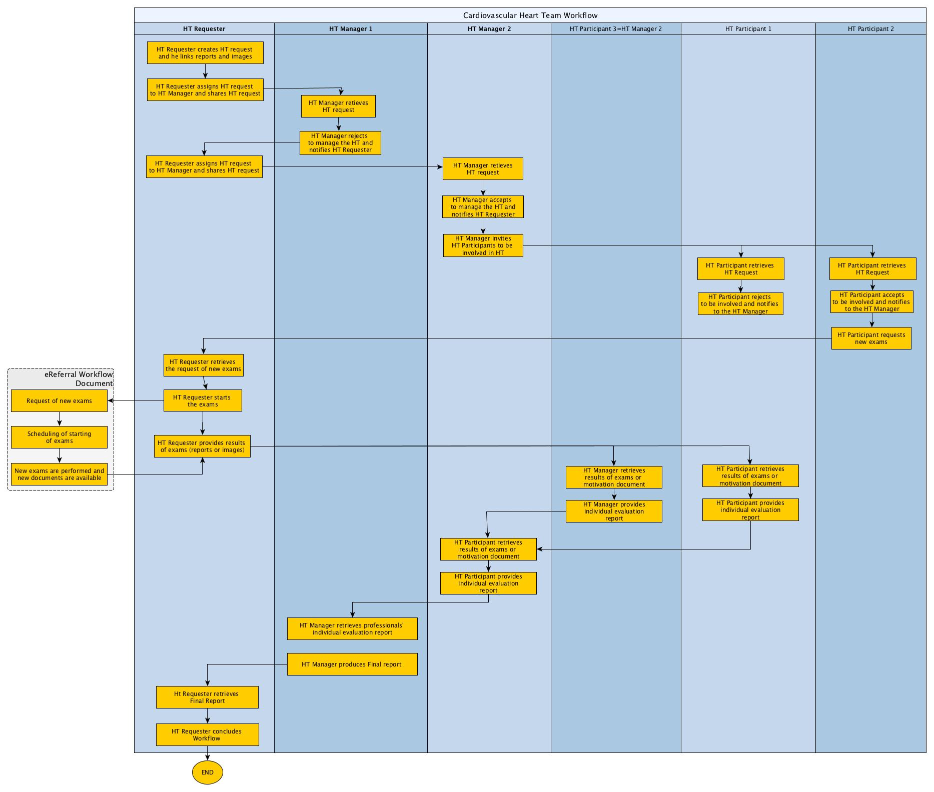**Figure Appendix C-2: XCHT-WD process flow of actors for use case 2 (section X.4.2.2):** It illustrates the workflow of management of a Cross-enterprise Cardiovascular Heart Team composed of other professionals besides the requester and manager of Heart Team. This use case describes also the reject of management of the HT and the assignment to another manager, and the reject of to be involved to HT as participant.

Glossary

HT: Heart Team

Volume 2 – Transactions

## 3.Y1 Submit and assign HT Management [PCC-Y1]

### 3.Y1.1 Scope

The Submit and assign HT Management transaction starts a Heart Team process. It submits a new Workflow Document in order to provide the HT Request document to the HT Manager and/or to assign HT management to the HT Manager.

### 3.Y1.2 Actor Roles

HT Requester

XDS Document Repository

Figure 3.Y1.2-1: Use Case Diagram

Table 3.Y1.2-1: Actor Roles

|  |  |
| --- | --- |
| **Actor:** | HT Requester |
| **Role:** | Creates the Heart Team Workflow Document, assigns the HT management to a HT Manager that can manage the Heart Team, and submits the Heart Team Workflow Documents with associated metadata to a Document Repository. |
| **Actor:** | XDS Document Repository |
| **Role:** | Receives, stores and eventually notifies the Workflow Document |

### 3.Y1.3 Referenced Standards

**XDS.b (Cross-Enterprise Document Sharing):**  For a list of the standards for the underlying Provide and Register Document Set-b [ITI-41] transaction, see ITI TF-2b: 3.41.3.

**XDW (Cross-Enterprise Document Workflow):** For requirements and standards related to the Heart Team Workflow Document, see ITI TF-1:20 and ITI TF-3:4.5.

### 3.Y1.4 Interaction Diagram

HT Requester

Actor A

Submit and assign HT Management

XDS Document Repository

Actor D

Provide And Register Document set-b Response

Message 2

#### 3.Y1.4.1 Submit and assign HT Management

This message initiates the Heart Team workflow by sharing the Heart Team Workflow Document with the Document Repository in order to provide the HT Request Document to the HT Manager and to assign HT management to the HT Manager. Alternatively, this message can only assign HT management to another HT Manager, if a previous assignment was been rejected.

##### 3.Y1.4.1.1 Trigger Events

The HT Requester sends this message when:

1. It is ready to initiate the Heart Team process and has acquired and collected all the information needed, and the HT Request is ready to be assigned. This means that the HT Requester shall be able to identify a HT Manager that is able to manage the HT, but rules for assignment are out of scope for this specification, and should be locally defined by domain policies.

OR

1. A previous assignment to HT management is revoked by the HT Requester or rejected by the HT Manager and it has been assigned again. This means that the HT Requester shall be able to identify a HT Manager that is able to manage the HT, but rules for assignment are out of scope for this specification, and should be locally defined by domain policies.

The **pre-conditions** are encoded as:

1. The workflow document is open (**WorkflowDocument/workflowStatus**=”OPEN”) **and** the HT Request task is COMPLETED (WorkflowDocument/TaskList/XDWTask/taskData/taskDetails/status=”COMPLETED”and WorkflowDocument/TaskList/XDWTask/taskData/taskDetails/taskType=”HTRequest”) and each HT Lead task is “EXITED”(**WorkflowDocument/TaskList/XDWTask/taskData/taskDetails/status**=”EXITED” and **WorkflowDocument/TaskList/XDWTask/taskData/taskDetails/taskType**=”HTLead”)

##### The information needed are:

* Heart Team Request Document: the request for a HT to perform a Final Report for the clinical case.
* Images Manifest: a document identifying the key images set
* Images Report (Optional)
* Clinical Report (Optional)
* Clinical Videos (Optional)

##### 3.Y1.4.1.2 Message Semantics

This message is a Provide And Register Document Set-b Request message. This message shall comply with the message semantics defined for the Provide and Register Document Set-b Request message in ITI TF-2b:3.41.4.1.2. The HT Requester is the Document Source.

This section defines:

* The Heart Team Workflow Document Content submitted in the Provide and Register. See Section 3.Y1.4.1.2.1.
* The Heart Team Request Document Content submitted in the Provide and Register. See Section 3.Y1.4.1.2.2.
* The Document Sharing Metadata requirements for the Submission Set and Document Entry. See Section 3.Y1.4.1.2.3.

This specification does not require that all the documents referenced as input documents within the Workflow Document are included in the same submissionSet.

##### 3.Y1.4.1.2.1 Heart Team Workflow Document Content Requirements

The HT Requester initiates the workflow by creating a new Heart Team Workflow Document if no assignment has occurred. The Heart Team Workflow Document is updated by the HT Requester if a previous assignment is revoked by HT Requester or rejected by the HT Manager and it has been re-assigned.

##### 3.Y1.4.1.2.1.1 Workflow Document Elements

The HT Requester shall create a new Heart Team Workflow Document according to the definition of an XDW Workflow Document in ITI TF-3: 5.4 with the following constraints:

* **<WorkflowStatus>** shall be set to “OPEN”.
* **<workflowDefinitionReference>** shall be set to “1.2.3.4.5.6.7.8.9.0”.
* for **<TaskList>** constraints see Section 3.Y1.4.1.2.1.1.1.

If this message is only to assign HT management to the HT Manager, HT Requester shall update the Heart Team Workflow Document according to the definition of an XDW Workflow Document in ITI TF-3: 5.4 with the following constraint:

* For **<TaskList>** constraints see Section 3.Y1.4.1.2.1.1.1.

##### 3.Y1.4.1.2.1.1.1 Workflow Document taskList Element

This element shall be structured according to ITI TF-3:5.4.2.3 “XDW Workflow Document Elements from the OASIS Human Task,” with the additional constraints specified below.

If The HT Requester shall create a new Heart Team Workflow Document the HT Requester shall put the following in the **<TaskList>** element :

* a required **<XDWTask>** child element that represents the HT Request task. See Section 3.Y.4.1.2.1.1.1.1
* A required **<XDWTask>** child element that represents the HT Lead task. See Section 3.Y.4.1.2.1.1.1.2

If this message is only to assign HT management to HT Manager, the HT Requester shall put the following in the **<TaskList>** element :

* A required **<XDWTask>** child element that represents the HT Lead task. See Section 3.Y.4.1.2.1.1.1.2

Further requirements are defined in the next sections.

##### 3.Y1.4.1.2.1.1.1.1 XDW Task “HT Request”

The **<XDWTask>** sub element **<taskDetails>** describes the HT Request task details:

* the <**taskType>** child element shall have the value “HT Request”
* the <**status>** child element shall have thevalue “COMPLETED”.

The HT Requester actor **may** set the value of additional elements that characterize the nature and the execution of the HT Requested:

* **taskData/taskDetails/expirationTime**: this elements allows the HT Requester to specify a date/time by which the HT needs to be completed
* **taskData/taskDetails/notificationRecipients:**this elements identifies user/organization that needs to be notified. If this element has one or more values, the same user/organization shall be identified as SubmissionSet.intendedRecipient for the submission that will result in the publication of the Workflow Document itself.

The element **<XDWTask>** shall have a child element **taskData/input/part** for each input document referenced. The document referenced as input are listed below. Further details about attachment encoding within **taskData/input/part** are specified at ITI TF-3: Table 5.4.3-9 AttachmentInfo Element

* **part/@name** =”ClinicalDocuments”: [0..*] this is an optional and repeatable input that identifies relevant Clinical Document.
* **part/@name**=”ImageManifest”: [0..*] this is an optional and repeatable input that identifies the Image Manifest of the relevant images.
* **part/@name=**=”ClinicalVideos”: [0..*] this is an optional and repeatable input that identifies the the relevant videos

The element **<XDWTask>** shall have a child element **taskData/output/part** for each input document referenced. The document referenced as output are listed below. Further details about attachment encoding within **taskData/output/part** are specified at ITI TF-3: Table 5.4.3-9 AttachmentInfo Element

* **part/@name** =”HTRequest”: [1..1] this is a required output that identifies the HT Request document. See Section 3.Y1 4.1.2.2

The element **<XDWTask>** shall have only one child element **taskEventHistory/taskEvent** characterized by <**status>** = “COMLETED”.

##### 3.Y1.4.1.2.1.1.1.2 XDW Task “HT Lead”

The **<XDWTask>** sub element **<taskDetails>** describes the HT Lead task details:

* the <**taskType>** child element shall have the value “HTLead”
* the <**status>** child element shall have thevalue “READY”.

The HT Requester shall specify the identified HT Manager in the **<potentialOwner>** element:

* **taskData/taskDetails/potentialOwner:** this element allows to “reserve” the task for a HT Manager. The HT Manager can be a user. Only identified HT Manager can claim the task. This transaction does not define the criteria by which the HT Requester select a specific HT Manager.

The element **<XDWTask>** shall have a child element **taskData/input/part** for each input document referenced. The document referenced as input are listed below. Further details about attachment encoding within **taskData/input/part** are specified at ITI TF-3: Table 5.4.3-9 AttachmentInfo Element

* **part/@name** =”ClinicalDocuments”: [0..*] this is an optional and repeatable input that identifies relevant Clinical Document.
* **part/@name**=”ImageManifest”: [0..*] this is an optional and repeatable input that identifies the Image Manifest of the relevant images.
* **part/@name=**=”ClinicalVideos”: [0..*] this is an optional and repeatable input that identifies the the relevant videos
* **part/@name** =”HTRequest”: [1..1] this is a required input that identifies the HT Request document. See Section 3.Y1 4.1.2.2

The HT Requester shall specify the HT Manager identified as a “notificationRecipient” for the task:

* **taskData/taskDetails/notificationRecipients:** this elements specifies user/organization that needs to be notified.

The HT Requester may set the value of additional elements that characterize the nature and the execution of the HT:

* **taskData/taskDetails/expirationTime**: this element specifies a date/time by which the HT Manager have to accept or reject.

##### 3.Y1.4.1.2.2 HT Request Document Content Requirements

The HT Request Document shall contain the reason why the clinical case is submitted to the Heart Team. The document may contain supporting clinical information on the patient. This specification does not mandate any specific structure for this document

##### 3.Y1.4.1.2.3 Document Sharing Metadata Requirements

Document metadata for this transaction shall comply with the requirements in ITI TF-3:4 “Metadata used in Document Sharing Profiles”.

This section specifies additional Document Sharing Metadata requirements for the Heart Team Workflow Document.

The **DocumentEntry metadata of the Heart Team Workflow Document** shall meet the following constraints:

* The eventCodeList metadata attribute is used to document the current status of the workflow and the status of task(s) within the workflow. This enables queries or DSUB notifications about status based on the values in eventCodeList:
* A single entry of eventCodeList shall convey the actual status (OPEN) of the workflow: code = “urn:ihe:iti:xdw:2011:eventCode:open” codingScheme=” 1.3.6.1.4.1.19376.1.2.3”
* A single entry of the eventCodeList metadata shall convey the actual status of the HT Request task: code=”urn:ihe:pcc:xcht-wd:2015:eventCodeTaskStatus:HTRequestCompleted” codingScheme=”1.3.6.1.4.1.19376.1.2.1”
* A single entry of the eventCodeList metadata shall convey the status of the HT Lead task: code=”urn:ihe:pcc:xcht-wd:2015:eventCodeTaskStatus:HTLeadReady” codingScheme=”1.3.6.1.4.1.19376.1.2.1”
* The referenceIdList metadata shall provide the accession number in accordance with PCC TF-3: Table 4.68.4.1.2.3-1.
* The typeCode shall convey the following code: “XCHT-WD” codingScheme: 1.2.3.4.5.6.7.8.9.0

The **SubmissionSet metadata of the Heart Team Workflow Document** shall meet the following constraints:

* The intendedRecipient metadata contain the identifier of the organization, or the person intended to manage the HT. This metadata shall convey the same users/organizations identified within the Workflow Document in the **<notificationRecipients>**element of the HT Lead task

This transaction does not define document sharing metadata requirements for the HT Request document. The document may be included in the same Submission Set as the Heart Team Workflow Document in this transaction [PCC-Y1] or in a different Submission Set using a [ITI-41] Provide and Register Document Set-b transaction.

##### 3.Y1.4.1.3 Expected Actions

The HT Requester actor shall process the Provide and Register Document Set-b Request message as described in section ITI TF-2b:3.41.4.1.3.

#### 3.Y1.4.2 Provide And Register Document set-b Response

This specification does not add additional requirements for the Provide And Register Document Set-b Response message defined in ITI TF-2b:3.41.4.2.

##### 3.Y1.4.2.1 Trigger Events

See section ITI TF-2b:3.41.4.2.1

##### 3.Y1.4.2.2 Message Semantics

See section ITI TF-2b:3.41.4.2.2

##### 3.Y1.4.2.3 Expected Actions

See section ITI TF-2b:3.41.4.2.3.

In addition to the Expected Actions defined for the Provide And Register Document Set-b Response message, when the Document Repository sends a Response of Success (See ITI TF-3: 4.2.4.2)to the HT Requester actor, the HT Requester shall save the workflowInstanceId associated with the workflow for subsequents subscriptions or queries.

If an error is generated by the Document Repository that error should be managed by the HT Requester in accordance to local defined behaviors, and in accordance to XDW actor behaviors (race condition) defined in section ITI TF-3: 5.4.5.1

### 3.Y1.5 Security Considerations

#### See section ITI TF-2b:3.41.5.

#### 3.Y1.5.1 Security Audit Considerations

#### See section ITI TF-2b:3.41.5.1.

## 3.Y2 Accept/Reject HT Activity PCC-Y2

### 3.Y2.1 Scope

This transaction allows a HT Manager or HT participant to accept or reject the assignment respectively to manage the Heart Team or to be involved in the Heart Team.

### 3.Y2.2 Actor Roles

HT Manager or HT Participant

Actor ABC

XDS Document Repository

Figure 3.Y2.2-1: Use Case Diagram

Table 3.Y2.2-1: Actor Roles

|  |  |
| --- | --- |
| **Actor:** | HT Manager |
| **Role:** | Accepts or rejects the assignment to manage the Heart Team |
| **Actor:** | HT Participant |
| **Role:** | Accepts or rejects the assignment to be involved in the Heart Team. |
| **Actor:** | XDS Document Repository |
| **Role:** | Receives and stores the updated Workflow Document |

### 3.Y2.3 Referenced Standards

**XDS.b (Cross-Enterprise Document Sharing):**  For a list of the standards for the underlying Provide and Register Document Set-b [ITI-41] transaction, see ITI TF-2b: 3.41.3.

**XDW (Cross-Enterprise Document Workflow):** For requirements and standards related to the Heart Team Workflow Document, see ITI TF-1:20 and ITI TF-3:4.5.

### 3.Y2.4 Interaction Diagram

HT Manager or HT Participant

Actor A

Accept/Reject HT Activity

XDS Document Repository

Actor D

Provide And Register Document set-b Response

Message 2

#### 3.Y2.4.1 Accept/Reject HT Activity

This message accept/reject the assignment to manage the Heart Team requested, through PCC-Y1 or the assignment to be involved in the Heart Team, requested through PCC-Y3.

##### 3.Y2.4.1.1 Trigger Events

The HT Manager or HT Participant sends this message when it learns that respectively a HT Lead or HT Involvement task has been assigned to itself. The mechanism to learn this is not defined by this transaction.

If the sender is the HT Manager, the **pre-conditions** are encoded as:

1. The HT Lead task is assigned to the HT Manager if the workflow document is open (**WorkflowDocument/workflowStatus**=”OPEN”) and “HT Lead” Task is READY and assigned to HT Manager (**WorkflowDocument/TaskList/XDWTask/taskData/taskDetails/status**=”READY” and **WorkflowDocument/TaskList/XDWTask/taskData/taskDetails/taskType**=”HTLead” and **WorkflowDocument/TaskList/XDWTask/taskData/taskDetails/potentialOwners**=HT Manager)

If the sender is the HT Participant, the **pre-conditions** are encoded as:

1. The HT Involvement task is assigned to the HT Participant if the workflow document is open (**WorkflowDocument/workflowStatus**=”OPEN”) and “HT Involvement” Task is READY and assigned to HT Participant (**WorkflowDocument/TaskList/XDWTask/taskData/taskDetails/status**=”READY” and **WorkflowDocument/TaskList/XDWTask/taskData/taskDetails/taskType**=”HTInvolvement” and **WorkflowDocument/TaskList/XDWTask/taskData/taskDetails/potentialOwners**=HT Participant).

Note: this transaction does not define a method for identifying HT Manager or HT Participant.

##### 3.Y2.4.1.2 Message Semantics

This message is a Provide and Register Document Set-b Request message. This message shall comply with the message semantics defined for the Provide and Register Document Set-b Request message in ITI TF-2b:3.41.4.1.2. The HT Manager or HT Participant is the Document Source.

This section also defines:

* The Heart Team Workflow Document Content submitted in the Provide and Register. See Section 3.Y2.4.1.2.1.
* The Document Sharing Metadata requirements for the Submission Set and Document Entry. See Section 3.Y2.4.1.2.3.

##### 3.Y2.4.1.2.1 Heart Team Workflow Document Content Requirements

The Heart Team Workflow Document is updated by the HT Manager or HT Participant.

##### 3.Y2.4.1.2.1.1 Workflow Document Elements

The HT Manager or HT Participant shall update the Heart Team Workflow Document according to the definition of an XDW Workflow Document in ITI TF-3: 5.4

This transaction does not require the creation of new tasks within the Workflow Document; however, it requires the HT Manager or HT Participant to add a new **taskEvent** respectively in the HT Lead task or in HT Involvement. See respectively Section 3.Y2.4.1.2.1.1.1 or 3.Y2.4.1.2.1.1.2

##### 3.Y2.4.1.2.1.1.1 XDWTask “HT Lead”

If the HT Manager is accepting the assignment to manage Heart Team, a new **<taskEvent>** (characterized by: status=COMPLETED, eventType=”start”) shall be added to the **<taskEventHistory>** element.

If the HT Manager is rejecting the assignment to manage Heart Team, a new **<taskEvent>** (characterized by: status=EXITED, eventType=”skip”) shall be added to the **<taskEventHistory>** element.

The HT Manager shall populate **taskData/comments** child element of the updated task with reasons for rejection.

##### 3.Y2.4.1.2.1.1.2 XDWTask “HT Involvement”

If the HT Participant is accepting the assignment to manage Heart Team, a new **<taskEvent>** (characterized by: status=IN_PROGRESS, eventType=”start”) shall be added to the **<taskEventHistory>** element.

If the HT Participant is rejecting the assignment to manage Heart Team, a new **<taskEvent>** (characterized by: status=EXITED, eventType=”skip”) shall be added to the **<taskEventHistory>** element.

The HT Participant shall populate **taskData/comments** child element of the updated task with reasons for rejection.

##### 3.Y2.4.1.2.2 Document Sharing Metadata requirements

Document metadata for this transaction shall comply with the requirements in ITI TF-3:4 “Metadata used in Document Sharing Profiles”.

This section specifies additional Document Sharing Metadata requirements for the Heart Team Workflow Document.

The **DocumentEntry metadata of the Heart Team Workflow Document** shall meet the following constraints:

* The eventCodeList metadata attribute is used to document the current status of the workflow and the status of task(s) within the workflow. This enables queries or DSUB notifications about status based on the values in eventCodeList:
* A single entry of eventCodeList metadata shall convey the current status (OPEN) of the workflow: code = “urn:ihe:iti:xdw:2011:eventCode:open” codingScheme=” 1.3.6.1.4.1.19376.1.2.3”
* If sender is a HT Manager, a single entry of the eventCodeList metadata shall convey the current status of the HT Lead task. The value shall be one of:
  + code=”urn:ihe:pcc:xcht-wd:2015:eventCodeTaskStatus:HTLeadExited” codingScheme=”1.3.6.1.4.1.19376.1.2.1”
  + code=”urn:ihe:pcc:xcht-wd:2015:eventCodeTaskStatus:HTLeadCompleted” codingScheme=”1.3.6.1.4.1.19376.1.2.1”

OR

* If sender is a HT Participant, a single entry of the eventCodeList metadata shall convey the current status of the HT Involvement task. The value shall be one of:
  + code=”urn:ihe:pcc:xcht-wd:2015:eventCodeTaskStatus:HTInvolvementExited” codingScheme=”1.3.6.1.4.1.19376.1.2.1”
  + code=”urn:ihe:pcc:xcht-wd:2015:eventCodeTaskStatus:HTInvolvementInprogress” codingScheme=”1.3.6.1.4.1.19376.1.2.1”

##### 3.Y2.4.1.3 Expected Actions

The Document Repository actor shall process the Provide and Register Document Set-b Request message as described in ITI TF-2b:3.41.4.1.3.

#### 3.Y2.4.2 Provide and Register Document set-b Response

This specification does not add additional requirements for the Provide and Register Document Set-b Response message defined in ITI TF-2b:3.41.4.2.

##### 3.Y2.4.2.1 Trigger Events

See ITI TF-2b:3.41.4.2.1

##### 3.Y2.4.2.2 Message Semantics

See ITI TF-2b:3.41.4.2.2

##### 3.Y2.4.2.3 Expected Actions

See section ITI TF-2b:3.41.4.2.3.

In addition to the Expected Actions defined for the Provide And Register Document Set-b Response message, when the Document Repository sends a Response of Success (See ITI TF-3: 4.2.4.2)to the HT Manager or HT Participant actor, the HT Requester shall save the workflowInstanceId associated with the workflow for subsequent subscriptions or queries.

If an error is generated by the Document Repository, that error should be managed by the HT Manager or HT Participant in accordance to local defined behaviors, and in accordance to XDW actor behaviors (race condition) defined in section ITI TF-3: 5.4.5.1

### 3.Y2.5 Security Considerations

#### See ITI TF-2b:3.41.5.

#### 3.Y2.5.1 Security Audit Considerations

#### See ITI TF-2b:3.41.5.1.

## 3.Y3 Assign HT Participation [PCC-Y3]

### 3.Y3.1 Scope

The Assign HT Participation transaction updates the Workflow Document in order to assign HT participation to each HT Participant. The identification of which group of HT Participants to be involved in Heart Team is out of scope for this specification and should be locally defined by domain policies.

### 3.Y3.2 Actor Roles

HT Manager

XDS Document Repository

Figure 3.Y.2-1: Use Case Diagram

Table 3.Y.2-1: Actor Roles

|  |  |
| --- | --- |
| **Actor:** | HT Manager |
| **Role:** | Assigns the HT participation to HT Participants that can provide advice to the Heart Team, updates Heart Team Workflow Documents and submits the updated Heart Team Workflow Documents to a Document Repository. |
| **Actor:** | XDS Document Repository |
| **Role:** | Receives, stores and eventually notifies the updated Workflow Document |

### 3.Y3.3 Referenced Standards

**XDS.b (Cross-Enterprise Document Sharing):**  For a list of the standards for the underlying Provide and Register Document Set-b [ITI-41] transaction, see ITI TF-2b: 3.41.3.

**XDW (Cross-Enterprise Document Workflow):** For requirements and standards related to the Heart Team Workflow Document, see ITI TF-1:20 and ITI TF-3:4.5.

### 3.Y3.4 Interaction Diagram

HT Manager

Actor A

Assign HT Participation

XDS Document Repository

Actor D

Provide And Register Document set-b Response

Message 2

#### 3.Y3.4.1 Assign HT Participation

This message assigns HT participation to each HT Participant that has to be involved in the Heart Team.

##### 3.Y3.4.1.1 Trigger Events

The HT Manager sends this message when it has accepted to manage the HT and is ready to identify HT Participants able to be involved in the Heart Team. Rules for assignment are out of scope for this specification, and should be locally defined by domain policies.

The **pre-conditions** are encoded as:

The workflow document is active (**WorkflowDocument/workflowStatus**=”OPEN”)and one HT Lead task is “COMPLETED”(**WorkflowDocument/TaskList/XDWTask/taskData/taskDetails/status**=”COMPLETED” and **WorkflowDocument/TaskList/XDWTask/taskData/taskDetails/taskType**=”HTLead”)

##### 3.Y3.4.1.2 Message Semantics

This message is a Provide And Register Document Set-b Request message. This message shall comply with the message semantics defined for the Provide and Register Document Set-b Request message in ITI TF-2b:3.41.4.1.2. The HT Requester is the Document Source.

This section defines:

* The Heart Team Workflow Document Content submitted in the Provide and Register. See Section 3.Y3.4.1.2.1.
* The Document Sharing Metadata requirements for the Submission Set and Document Entry. See Section 3.Y3.4.1.2.3.

##### 3.Y3.4.1.2.1 Heart Team Workflow Document Content Requirements

The Heart Team Workflow Document is updated by the HT Manager.

##### 3.Y3.4.1.2.1.1 Workflow Document Elements

The HT Manager shall update the Heart Team Workflow Document according to the definition of an XDW Workflow Document in ITI TF-3: 5.4 with the following constraints:

* for **<TaskList>** constraints see Section 3.Y3.4.1.2.1.1.1

##### 3.Y3.4.1.2.1.1.1 Workflow Document taskList Element

This element shall be structured according to ITI TF-3:5.4.2.3 “XDW Workflow Document Elements from the OASIS Human Task,” with the additional constraints specified below.

The HT Manager shall put in the **<TaskList>** element:

* One or more **<XDWTask>** child elements that represents the HT Involvement tasks, one **<XDWTask>** for each HT Participant that has to be involved in Heart Team. See Section 3.Y3.4.1.2.1.1.1.1

Further requirements are defined in the next sections.

##### 3.Y3.4.1.2.1.1.1.1 XDW Task “HT Invitation”

The **<XDWTask>** sub element **<taskDetails>** describes the HT Involvement task details:

* the <**taskType>** child element shall have the value “HTInvitation”
* the <**status>** child element shall have thevalue “READY”.

The HT Manager shall specify the identified HT Participant in the **<potentialOwner>** element:

* **taskData/taskDetails/potentialOwner:** this element allows to “reserve” the task for a HT Participant. The HT Participant can be a user. Only identified HT Participant can claim the task. This transaction does not define how to identify a HT Participant.

The element **<XDWTask>** shall have a child element **taskData/input/part** for each input document referenced. The document referenced as input are listed below. Further details about attachment encoding within **taskData/input/part** are specified at ITI TF-3: Table 5.4.3-9 AttachmentInfo Element

* **part/@name** =”ClinicalDocuments”: [0..*] this is an optional and repeatable input that identifies relevant Clinical Document.
* **part/@name**=”ImageManifest”: [0..*] this is an optional and repeatable input that identifies the Image Manifest of the relevant images.
* **part/@name=**=”ClinicalVideos”: [0..*] this is an optional and repeatable input that identifies the the relevant videos
* **part/@name** =”HTRequest”: [1..1] this is a required input that identifies the HT Request document. See Section 3.Y1 4.1.2.2

The HT Manager shall specify the HT Participant identified as a “notificationRecipient” for the task:

* **taskData/taskDetails/notificationRecipients:** this element specifies user/organization that needs to be notified.

The HT Manager could set the value of additional elements that characterize the nature and the execution of the HT:

* **taskData/taskDetails/expirationTime**: this element specifies a date/time by which the accept or rejection needs to be completed

##### 3.Y3.4.1.2.2 Document Sharing Metadata Requirements

Document metadata for this transaction shall comply with the requirements in ITI TF-3:4 “Metadata used in Document Sharing Profiles”.

This section specifies additional Document Sharing Metadata requirements for the Heart Team Workflow Document.

The **DocumentEntry metadata of the Heart Team Workflow Document** shall meet the following constraints:

* The eventCodeList metadata attribute is used to document the current status of the workflow and the status of task(s) within the workflow. This enables queries or DSUB notifications about status based on the values in eventCodeList:
  + A single entry of eventCodeList shall convey the actual status (OPEN) of the workflow: code = “urn:ihe:iti:xdw:2011:eventCode:open” codingScheme=” 1.3.6.1.4.1.19376.1.2.3”
  + A single entry of the eventCodeList metadata for each HT Invitation shall convey the status of the HT Invitation task: code=”urn:ihe:pcc:xcht-wd:2015:eventCodeTaskStatus:HTInvitationReady” codingScheme=”1.3.6.1.4.1.19376.1.2.1”

The **SubmissionSet metadata of the Heart Team Workflow Document** shall meet the following constraints:

* The intendedRecipient metadata contain the identifier of the organization, or the person intended to be involved in the Heart Team. This metadata shall convey the same users/organizations identified within the Workflow Document in the **<notificationRecipients>**element of the HT Involvement task.

##### 3.Y3.4.1.3 Expected Actions

The Document Repository actor shall process the Provide and Register Document Set-b Request message as described in section ITI TF-2b:3.41.4.1.3.

#### 3.Y3.4.2 Provide And Register Document set-b Response

This specification does not add additional requirements for the Provide And Register Document Set-b Response message defined in ITI TF-2b:3.41.4.2.

##### 3.Y3.4.2.1 Trigger Events

See section ITI TF-2b:3.41.4.2.1

##### 3.Y3.4.2.2 Message Semantics

See section ITI TF-2b:3.41.4.2.2

##### 3.Y3.4.2.3 Expected Actions

See section ITI TF-2b:3.41.4.2.3.

If an error is generated by the Document Repository that error should be managed by the HT Manager in accordance to local defined behaviors, and in accordance to XDW actor behaviors (race condition) defined in section ITI TF-3: 5.4.5.1

### 3.Y3.5 Security Considerations

#### See section ITI TF-2b:3.41.5.

#### 3.Y3.5.1 Security Audit Considerations

#### See section ITI TF-2b:3.41.5.1.

## 3.Y4 Add request of more clinical information [PCC-Y4]

### 3.Y4.1 Scope

The Add Request of more clinical information transaction updates and submits an updated Workflow Document, in order to allow each HT Participant to request that HT Requester provides more clinical information.

### 3.Y4.2 Actor Roles

HT Participant

XDS Document Repository

Figure 3.Y4.2-1: Use Case Diagram

Table 3.Y4.2-1: Actor Roles

|  |  |
| --- | --- |
| **Actor:** | HT Participant |
| **Role:** | Requests that HT Requester provides more clinical information, updates and submits the Heart Team Workflow Documents with associated metadata to a Document Repository. |
| **Actor:** | XDS Document Repository |
| **Role:** | Receives, stores and eventually notifies the Workflow Document |

### 3.Y4.3 Referenced Standards

**XDS.b (Cross-Enterprise Document Sharing):**  For a list of the standards for the underlying Provide and Register Document Set-b [ITI-41] transaction, see ITI TF-2b: 3.41.3.

**XDW (Cross-Enterprise Document Workflow):** For requirements and standards related to the Heart Team Workflow Document, see ITI TF-1:20 and ITI TF-3:4.5.

### 3.Y4.4 Interaction Diagram

HT Participant

Actor A

Add Request of more clinical information

XDS Document Repository

Actor D

Provide And Register Document set-b Response

Message 2

#### 3.Y4.4.1 Add Request of more clinical information

This message requests that HT Requester provides more clinical information to Heart Team.

##### 3.Y4.4.1.1 Trigger Events

The HT Participant sends this message when it has accepted to be involved in the HT and is ready to request that HT Requester provides more clinical information to the Heart Team.

The **pre-conditions** are encoded as:

The workflow document is open (**WorkflowDocument/workflowStatus**=”OPEN”) **and t**he HT Involvement task to which HT participant is owner is “IN PROGRESS”(**WorkflowDocument/TaskList/XDWTask/taskData/taskDetails/status**=”IN PROGRESS” and **WorkflowDocument/TaskList/XDWTask/taskData/taskDetails/taskType**=”HTInvolvment”)

##### The information needed is:

* Request of more information document: the request for HT Requester to provide more clinical information (reports, images, etc).

##### 3.Y4.4.1.2 Message Semantics

This message is a Provide And Register Document Set-b Request message. This message shall comply with the message semantics defined for the Provide and Register Document Set-b Request message in ITI TF-2b:3.41.4.1.2. The HT Participant is the Document Source

This section defines:

* The Heart Team Workflow Document Content submitted in the Provide and Register. See Section 3.Y4.4.1.2.1.
* The Heart Team Request of more clinical information content submitted in the Provide and Register. See Section 3.Y4.4.1.2.2..
* The Document Sharing Metadata requirements for the Submission Set and Document Entry. See Section 3.Y4.4.1.2.3.

##### 3.Y4.4.1.2.1 Heart Team Workflow Document Content Requirements

The Heart Team Workflow Document is updated by the HT Participant.

##### 3.Y4.4.1.2.1.1 Workflow Document Elements

The HT Participant shall update the Heart Team Workflow Document according to the definition of an XDW Workflow Document in ITI TF-3: 5.4 with the following constraints:

* for **<TaskList>**constraints see Section 3.Y4.4.1.2.1.1.1

##### 3.Y4.4.1.2.1.1.1 Workflow Document taskList Element

This element shall be structured according to ITI TF-3:5.4.2.3 “XDW Workflow Document Elements from the OASIS Human Task,” with the additional constraints specified below.

The HT Participant shall put in the **<TaskList>** element:

* One or more **<XDWTask>** child element that represents the HT Preparation tasks, one **<XDWTask>** for each HT Participant that has to be involved in Heart Team and for each request of more information. See Section 3.Y4.4.1.2.1.1.1.1

Further requirements are defined in the next sections.

##### 3.Y4.4.1.2.1.1.1.1 XDW Task “HT Preparation”

The **<XDWTask>** sub element **<taskDetails>** describes the HT Preparation task details:

* the <**taskType>** child element shall have the value “HT Preparation”
* the <**status>** child element shall have th**e** value “READY”.

The HT Participant shall specify the HT Requester in the **<potentialOwner>** element:

* **taskData/taskDetails/potentialOwner:** this element allows to “reserve” the task for a HT Requester. Only identified HT Requester can claim the task.

The HT Participant shall specify the HT Requester identified as a “notificationRecipient” for the task:

* **taskData/taskDetails/notificationRecipients:** this elements specifies user/organization that needs to be notified.

The HT Participant **may** set the value of additional elements that characterize the nature and the execution of the activity requested:

* **taskData/taskDetails/expirationTime**: this elements allows the HT Participant to specify a date/time by which the task needs to be completed

The element **<XDWTask>** shall have a child element **taskData/input/part** for each input document referenced. The document referenced as input are listed below. Further details about attachment encoding within **taskData/input/part** are specified at ITI TF-3: Table 5.4.3-9 AttachmentInfo Element

* **part/@name** =”HTRequestMoreInformation”: [1..1] this is a required input that identifies the Request of more information document**.**  See Section 3.Y4 4.1.2.2.

##### 3.Y4.4.1.2.2 Request of more information document Content Requirements

The Request of more information document shall contain the list of information the participants need before the Heart Team discussion occurs. This specification does not mandate any specific structure for this document.

##### 3.Y4.4.1.2.3 Document Sharing Metadata Requirements

Document metadata for this transaction shall comply with the requirements in ITI TF-3:4 “Metadata used in Document Sharing Profiles”.

This section specifies additional Document Sharing Metadata requirements for the both the Heart Team Workflow Document and for the Request of more information document.

The **DocumentEntry metadata of the Heart Team Workflow Document** shall meet the following constraints:

* The eventCodeList metadata attribute is used to document the current status of the workflow and the status of task(s) within the workflow. This enables queries or DSUB notifications about status based on the values in eventCodeList:
* A single entry of eventCodeList shall convey the actual status (OPEN) of the workflow: code = “urn:ihe:iti:xdw:2011:eventCode:open” codingScheme=” 1.3.6.1.4.1.19376.1.2.3”
* A single entry of the eventCodeList metadata for each HT Preparation task shall convey the status of the HT Preparation task: code=”urn:ihe:pcc:xcht-wd:2015:eventCodeTaskStatus:HTPreparationReady” codingScheme=”1.3.6.1.4.1.19376.1.2.1”

The **SubmissionSet metadata of the Heart Team Workflow Document** shall meet the following constraints:

* The intendedRecipient metadata contain the identifier of the organization, or the person intended to provide more clinical information. This metadata shall convey the same users/organizations identified within the Workflow Document in the **<notificationRecipients>**element of the HT Preparation task

This transaction does not define document sharing metadata requirements for the Request of more information document. The document may be included in the same Submission Set as the Heart Team Workflow Document in this transaction ([PCC-Y4]) or in a different Submission Set using a [ITI-41] Provide and Register Document Set-b transaction.

##### 3.Y4.4.1.3 Expected Actions

The Document Repository actor shall process the Provide and Register Document Set-b Request message as described in section ITI TF-2b:3.41.4.1.3.

#### 3.Y4.4.2 Provide And Register Document set-b Response

This specification does not add additional requirements for the Provide And Register Document Set-b Response message defined in ITI TF-2b:3.41.4.2.

##### 3.Y4.4.2.1 Trigger Events

See section ITI TF-2b:3.41.4.2.1

##### 3.Y4.4.2.2 Message Semantics

See section ITI TF-2b:3.41.4.2.2

##### 3.Y4.4.2.3 Expected Actions

See section ITI TF-2b:3.41.4.2.3.

If an error is generated by the Document Repository, that error should be managed by the HT Participant in accordance to local defined behaviors, and in accordance to XDW actor behaviors (race condition) defined in section ITI TF-3: 5.4.5.1

### 3.Y4.5 Security Considerations

#### See section ITI TF-2b:3.41.5.

#### 3.Y4.5.1 Security Audit Considerations

#### See section ITI TF-2b:3.41.5.1.

## 3.Y5 Add more clinical information [PCC-Y5]

### 3.Y5.1 Scope

The Add more clinical information transaction updates and submits an updated Workflow Document which provides clinical information requested by one or more PCC-Y4 transactions.

### 3.Y5.2 Actor Roles

HT Requester

XDS Document Repository

Figure 3.Y4.2-1: Use Case Diagram

Table 3.Y4.2-1: Actor Roles

|  |  |
| --- | --- |
| **Actor:** | HT Requester |
| **Role:** | Provides more clinical information requested by HT Participants, updates and submits the Heart Team Workflow Documents with associated metadata to a Document Repository. |
| **Actor:** | XDS Document Repository |
| **Role:** | Receives, stores and eventually notifies the Workflow Document |

### 3.Y5.3 Referenced Standards

**XDS.b (Cross-Enterprise Document Sharing):**  For a list of the standards for the underlying Provide and Register Document Set-b [ITI-41] transaction, see ITI TF-2b: 3.41.3.

**XDW (Cross-Enterprise Document Workflow):** For requirements and standards related to the Heart Team Workflow Document, see ITI TF-1:20 and ITI TF-3:4.5.

### 3.Y5.4 Interaction Diagram

HT Requester

Actor A

Add more clinical information

XDS Document Repository

Actor D

Provide And Register Document set-b Response

Message 2

#### 3.Y5.4.1 Add more clinical information

This message provides more clinical information to the Heart Team.This messageprovides clinical information requested by one or more PCC-Y4 transactions from each HT Participant. This mean that it concludes HT Preparation tasks generated by HT Participants for HT Requester.

##### 3.Y5.4.1.1 Trigger Events

The HT Requester sends this message when is ready to respond to request of information *by* Heart Team.

The **pre-conditions** are encoded as:

The workflow document is open (**WorkflowDocument/workflowStatus**=”OPEN”) **and t**he HT Preparation task is “READY”(**WorkflowDocument/TaskList/XDWTask/taskData/taskDetails/status**=”READY” and **WorkflowDocument/TaskList/XDWTask/taskData/taskDetails/taskType**=”HTPreparation”)

##### The information needed are one or more of these:

* Basic ePrescription Workflow Document
* Images Manifest: a document identifying the key images set
* Images Report
* Clinical Report
* Clinical Videos

##### 3.Y5.4.1.2 Message Semantics

This message is a Provide And Register Document Set-b Request message. This message shall comply with the message semantics defined for the Provide and Register Document Set-b Request message in ITI TF-2b:3.41.4.1.2. The HT Requester is the Document Source.

This section defines:

* The Heart Team Workflow Document Content submitted in the Provide and Register. See Section 3.Y4.4.1.2.1.
* The Document Sharing Metadata requirements for the Submission Set and Document Entry. See Section 3.Y4.4.1.2.3.

This specification does not require that all the documents referenced as input documents within the Workflow Document are included in the same submissionSet.

##### 3.Y5.4.1.2.1 Heart Team Workflow Document Content Requirements

The Heart Team Workflow Document is updated by the HT Requester.

##### 3.Y5.4.1.2.1.1 Workflow Document Elements

The HT Requester shall update the Heart Team Workflow Document according to the definition of an XDW Workflow Document in ITI TF-3: 5.4.

This transaction does not require the creation of new tasks within the Workflow Document; however, it requires the HT Requester to add a new **taskEvent** in each HT Preparation task. See Section 3.VV.4.1.2.1.1.1.

##### 3.Y5.4.1.2.1.1.1.1 XDW Task “HT Preparation”

If the HT Requester is ready to provide requested information to Heart Team, a new **<taskEvent>** (characterized by: status=COMPLETED, eventType=”start”) shall be added to the **<taskEventHistory>** element.

The element **<XDWTask>** shall have a child element **taskData/output/part** for each output document referenced. The document referenced as output are listed below. At least one document have to be presence. Further details about attachment encoding within **taskData/output/part** are specified at ITI TF-3: Table 5.4.3-9 AttachmentInfo Element

* **part/@name** =”xbepWorkflowDocument”: [0..*] this is an optional and repeatable output that identifies other Basic ePrescription Workflows.
* **part/@name** =”ClinicalDocuments”: [0..*] this is an optional and repeatable output that identifies relevant Clinical Document.
* **part/@name**=”ImageManifest”: [0..*] this is an optional and repeatable output that identifies the Image Manifest of the relevant images.
* **part/@name=**=”ClinicalVideo”: [0..*] this is an optional and repeatable output that identifies the the relevant videos

If the HT Requester cannot provide requested information in HT Preparation task, a new **<taskEvent>** (characterized by: status= EXITED, eventType=”start”) shall be added to the **<taskEventHistory>** element.

The HT Requester shall populate **taskData/comments** child element of the updated task with reasons for which cannot provide information.

##### 3.Y5.4.1.2.2 Document Sharing Metadata Requirements

Document metadata for this transaction shall comply with the requirements in ITI TF-3:4 “Metadata used in Document Sharing Profiles”.

This section specifies additional Document Sharing Metadata requirements for the Heart Team Workflow Document.

The **DocumentEntry metadata of the Heart Team Workflow Document** shall meet the following constraints:

* The eventCodeList metadata attribute is used to document the current status of the workflow and the status of task(s) within the workflow. This enables queries or DSUB notifications about status based on the values in eventCodeList:
* A single entry of eventCodeList shall convey the actual status (OPEN) of the workflow: code = “urn:ihe:iti:xdw:2011:eventCode:open” codingScheme=” 1.3.6.1.4.1.19376.1.2.3”
* A single entry of the eventCodeList metadata for each HT Preparation task shall convey the status of the HT Preparation task. The value shall be one of:
  + code=”urn:ihe:pcc:xcht-wd:2015:eventCodeTaskStatus:HTPreparationCompleted” codingScheme=”1.3.6.1.4.1.19376.1.2.1”

OR

* + code=”urn:ihe:pcc:xcht-wd:2015:eventCodeTaskStatus:HTPreparationExited” codingScheme=”1.3.6.1.4.1.19376.1.2.1”

##### 3.Y5.4.1.3 Expected Actions

The Document Repository actor shall process the Provide and Register Document Set-b Request message as described in section ITI TF-2b:3.41.4.1.3.

#### 3.Y5.4.2 Provide And Register Document set-b Response

This specification does not add additional requirements for the Provide And Register Document Set-b Response message defined in ITI TF-2b:3.41.4.2.

##### 3.Y5.4.2.1 Trigger Events

See section ITI TF-2b:3.41.4.2.1

##### 3.Y5.4.2.2 Message Semantics

See section ITI TF-2b:3.41.4.2.2

##### 3.Y5.4.2.3 Expected Actions

See section ITI TF-2b:3.41.4.2.3.

If an error is generated by the Document Repository, that error should be managed by the HT Requester in accordance to local defined behaviors, and in accordance to XDW actor behaviors (race condition) defined in section ITI TF-3: 5.4.5.1

### 3.Y5.5 Security Considerations

#### See section ITI TF-2b:3.41.5.

#### 3.Y5.5.1 Security Audit Considerations

#### See section ITI TF-2b:3.41.5.1.

## 3.Y6 Complete individual preparation [PCC-Y6]

### 3.Y6.1 Scope

The Complete individual preparation transaction updates and submits an updated Workflow Document, in order to inform Heart Team that HT Participant has concluded the preliminary phase (Involvement task and Preparation task). In this transaction the HT Participant may provide Individual evaluation report to support the Heart Team.

### 3.Y6.2 Actor Roles

HT Participant

XDS Document Repository

Figure 3.Y6.2-1: Use Case Diagram

Table 3.Y6.2-1: Actor Roles

|  |  |
| --- | --- |
| **Actor:** | HT Participant |
| **Role:** | Concludes preliminary phase, provides Individual evaluation report, updates and submits updates of the Heart Team Workflow Documents with associated metadata to a Document Repository. |
| **Actor:** | XDS Document Repository |
| **Role:** | Receives, stores and eventually notifies the Workflow Document |

### 3.Y6.3 Referenced Standards

**XDS.b (Cross-Enterprise Document Sharing):**  For a list of the standards for the underlying Provide and Register Document Set-b [ITI-41] transaction, see ITI TF-2b: 3.41.3.

**XDW (Cross-Enterprise Document Workflow):** For requirements and standards related to the Heart Team Workflow Document, see ITI TF-1:20 and ITI TF-3:4.5.

### 3.Y6.4 Interaction Diagram

HT Participant

Actor A

Complete individual preparation

XDS Document Repository

Actor D

Provide And Register Document set-b Response

Message 2

#### 3.Y6.4.1 Complete individual preparation

This message informs the Heart Team that HT Participant has concluded the preparation phase (Involvement task and Preparation task), providing Individual evaluation report to support the Heart Team.

##### 3.Y6.4.1.1 Trigger Events

The HT Participant sends this message after receiving all information by HT Requester, if needed, and is ready to provide Individual Evaluation Report to Heart Team.

The **pre-conditions** are encoded as:

1. The workflow document is open (**WorkflowDocument/workflowStatus**=”OPEN”) **and** if the HT Participant hasn’t created any HT Preparation tasks,  **t**he HT Involvement task is “IN PROGRESS”(**WorkflowDocument/TaskList/XDWTask/taskData/taskDetails/status**=”IN PROGRESS” and **WorkflowDocument/TaskList/XDWTask/taskData/taskDetails/taskType**=”HTInvolvement”)

OR

1. The workflow document is open (**WorkflowDocument/workflowStatus**=”OPEN”) **and** if the HT Participant has created HT Preparation tasks, **t**he HT Preparation task is “COMPLETED”or “EXITED”(**WorkflowDocument/TaskList/XDWTask/taskData/taskDetails/status**=”COMPLETED” or “EXITED ”and **WorkflowDocument/TaskList/XDWTask/taskData/taskDetails/taskType**=”HTPreparation”)

##### 3.Y6.4.1.2 Message Semantics

This message is a Provide And Register Document Set-b Request message. This message shall comply with the message semantics defined for the Provide and Register Document Set-b Request message in ITI TF-2b:3.41.4.1.2. The HT Participant is the Document Source.

This section defines:

* The Heart Team Workflow Document Content submitted in the Provide and Register. See Section 3.Y6.4.1.2.1.
* The Individual Evaluation Report Document submitted in the Provide and Register. See Section 3.Y6.4.1.2.2..
* The Document Sharing Metadata requirements for the Submission Set and Document Entry. See Section 3.Y6.4.1.2.3.

##### 3.Y6.4.1.2.1 Heart Team Workflow Document Content Requirements

The Heart Team Workflow Document is updated by the HT Participant.

##### 3.Y6.4.1.2.1.1 Workflow Document Elements

The HT Participant shall update the Heart Team Workflow Document according to the definition of an XDW Workflow Document in ITI TF-3: 5.4.

This transaction does not require the creation of new tasks within the Workflow Document; however, it requires the HT Participant to add a new **taskEvent** in the HT Involvement task. See Section 3.Y6.4.1.2.1.1.1.

##### 3.Y6.4.1.2.1.1.1.1 XDW Task “HT Involvement”

A new **<taskEvent>** (characterized by: status=COMPLETED, eventType=”start”) shall be added to the **<taskEventHistory>** element.

The HT Participant may update the element **<XDWTask>** to have a child element **taskData/output/part** where:

* **part/@name** =”IndividualEvaluationReport”: [0..1] this is an output that describe what HT Participant thinks on this clinical case and how professional thinks patient has to be trated.

##### 3.Y6.4.1.2.2 Individual Evaluation Report Content Requirements

The Individual Evaluation Report Document shall contain what the HT Participant input about this clinical case and the patient’s treatment plan, based on information provided by the HT Requester. This specification does not mandate any specific structure for this document.

##### 3.Y6.4.1.2.3 Document Sharing Metadata Requirements

Document metadata for this transaction shall comply with the requirements in ITI TF-3:4 “Metadata used in Document Sharing Profiles”.

This section specifies additional Document Sharing Metadata requirements for the Heart Team Workflow Document.

The **DocumentEntry metadata of the Heart Team Workflow Document** shall meet the following constraints:

* The eventCodeList metadata attribute is used to document the current status of the workflow and the status of task(s) within the workflow. This enables queries or DSUB notifications about status based on the values in eventCodeList:
* A single entry of eventCodeList shall convey the actual status (OPEN) of the workflow: code = “urn:ihe:iti:xdw:2011:eventCode:open” codingScheme=” 1.3.6.1.4.1.19376.1.2.3”
* A single eventCodeList metadata shall convey the status of the HT Preparation task: code=”urn:ihe:pcc:xcht-wd:2015:eventCodeTaskStatus:HTInvolvementCompleted” codingScheme=”1.3.6.1.4.1.19376.1.2.1”

This transaction does not define document sharing metadata requirements for the Individual Evaluation Report document. The document may be included in the same Submission Set as the Heart Team Workflow Document in this transaction ([PCC-Y6] Complete individual preparation) or in a different Submisstion Set using a [ITI-41] Provide and Register Document Set-b transaction.

##### 3.Y6.4.1.3 Expected Actions

The Document Repository actor shall process the Provide and Register Document Set-b Request message as described in section ITI TF-2b:3.41.4.1.3.

#### 3.Y6.4.2 Provide And Register Document set-b Response

This specification does not add additional requirements for the Provide And Register Document Set-b Response message defined in ITI TF-2b:3.41.4.2.

##### 3.Y6.4.2.1 Trigger Events

See section ITI TF-2b:3.41.4.2.1

##### 3.Y6.4.2.2 Message Semantics

See section ITI TF-2b:3.41.4.2.2

##### 3.Y6.4.2.3 Expected Actions

See section ITI TF-2b:3.41.4.2.3.

If an error is generated by the Document Repository that error should be managed by the HT Participant in accordance to local defined behaviors, and in accordance to XDW actor behaviors (race condition) defined in section ITI TF-3: 5.4.5.1

### 3.Y6.5 Security Considerations

#### See section ITI TF-2b:3.41.5.

#### 3.Y6.5.1 Security Audit Considerations

#### See section ITI TF-2b:3.41.5.1.

## 3.Y7 Plan HT Dicussion [PCC-Y7]

### 3.Y7.1 Scope

The Plan HT Discussion transaction updates Workflow Document in order to schedule the team’s communication among members of Heart Team.

### 3.Y7.2 Actor Roles

HT Manager

XDS Document Repository

Figure 3.Y.7-1: Use Case Diagram

Table 3.Y.7-1: Actor Roles

|  |  |
| --- | --- |
| **Actor:** | HT Manager |
| **Role:** | Schedules the team’s communication *among members of Heart Team*, updates Heart Team Workflow Documents and submits the updated Heart Team Workflow Documents to a Document Repository. |
| **Actor:** | XDS Document Repository |
| **Role:** | Receives, stores and eventually notifies the updated Workflow Document |

### 3.Y7.3 Referenced Standards

**XDS.b (Cross-Enterprise Document Sharing):**  For a list of the standards for the underlying Provide and Register Document Set-b [ITI-41] transaction, see ITI TF-2b: 3.41.3.

**XDW (Cross-Enterprise Document Workflow):** For requirements and standards related to the Heart Team Workflow Document, see ITI TF-1:20 and ITI TF-3:4.5.

### 3.Y7.4 Interaction Diagram

HT Manager

Actor A

Plan HT Discussion

XDS Document Repository

Actor D

Provide And Register Document set-b Response

Message 2

#### 3.Y7.4.1 Plan HT Discussion

This message schedules the team’s communication among members of Heart Team.

##### 3.Y7.4.1.1 Trigger Events

The HT Manager sends this message when all HT Participants have been involved in Heart Team, participants have received needed information, participants have provided individual evaluation report, and the HT Manager is ready to *schedule the team’s communication among members of Heart Team*.

The **pre-conditions** are encoded as:

The workflow document is active (**WorkflowDocument/workflowStatus**=”OPEN”) **and** all HT Involvement tasks are “COMPLETED”or “EXITED” (**WorkflowDocument/TaskList/XDWTask/taskData/taskDetails/status**=”COMPLETED” or “EXITED” and **WorkflowDocument/TaskList/XDWTask/taskData/taskDetails/taskType**=”HTInvolvement”)

##### 3.Y7.4.1.2 Message Semantics

This message is a Provide And Register Document Set-b Request message. This message shall comply with the message semantics defined for the Provide and Register Document Set-b Request message in ITI TF-2b:3.41.4.1.2. The HT Manager is the Document Source.

This section defines:

* The Heart Team Workflow Document Content submitted in the Provide and Register. See Section 3.Y7.4.1.2.1.
* The Document Sharing Metadata requirements for the Submission Set and Document Entry. See Section 3.Y7.4.1.2.3.

##### 3.Y7.4.1.2.1 Heart Team Workflow Document Content Requirements

The Heart Team Workflow Document is updated by the HT Manager.

##### 3.Y7.4.1.2.1.1 Workflow Document Elements

The HT Manager shall update the Heart Team Workflow Document according to the definition of an XDW Workflow Document in ITI TF-3: 5.4 with the following constraints:

* for **<TaskList>** constraints see Section 3.Y3.4.1.2.1.1.1

##### 3.Y7.4.1.2.1.1.1 Workflow Document taskList Element

This element shall be structured according to ITI TF-3:5.4.2.3 “XDW Workflow Document Elements from the OASIS Human Task,” with the additional constraints specified below.

The HT Manager shall put in the **<TaskList>** element:

* A **<XDWTask>** child element that represents the HT Perform task. See Section 3.Y7.4.1.2.1.1.1.1

Further requirements are defined in the next sections.

##### 3.Y7.4.1.2.1.1.1.1 XDW Task “HT Perform”

The **<XDWTask>** sub element **<taskDetails>** describes the HT Plan HT Discussion task details:

* the <**taskType>** child element shall have the value “HTPreform”
* the <**status>** child element shall have thevalue “IN PROGRESS”.

The HT Manager could set the value of additional elements that characterize the nature and the execution of the HT:

* **taskData/taskDetails/expirationTime**: this element specifies a date/time by which the Final Report needs to be completed.

The element **<XDWTask>** shall have a child element **taskData/input/part** for each input document referenced. The document referenced as input are listed below. Further details about attachment encoding within **taskData/input/part** are specified at ITI TF-3: Table 5.4.3-9 AttachmentInfo Element

* **part/@name** =”ClinicalDocuments”: [0..*] this is an optional and repeatable input that identifies relevant Clinical Document.
* **part/@name**=”ImageManifest”: [0..*] this is an optional and repeatable input that identifies the Image Manifest of the relevant images.
* **part/@name=**=”ClinicalVideos”: [0..*] this is an optional and repeatable input that identifies the the relevant videos
* **part/@name** =”HTRequest”: [1..1] this is a required input that identifies the HT Request document. See Section 3.Y1 4.1.2.2
* **part/@name** =”IndividualEvaluationReport”: [0..1] this is an output that describe what HT Participant thinks on this clinical case and how professional thinks patient has to be trated.

The HT Manager shall update the element **<XDWTask>** to have a child element **taskData/output/part** where:

* **part/@name** =”ConnectionPointInformation”: [1..1] this is an output that contain the link that allow to access to videoconference room, for example.

##### 3.Y7.4.1.2.2 Document Sharing Metadata Requirements

Document metadata for this transaction shall comply with the requirements in ITI TF-3:4 “Metadata used in Document Sharing Profiles”.

This section specifies additional Document Sharing Metadata requirements for the Heart Team Workflow Document.

The **DocumentEntry metadata of the Heart Team Workflow Document** shall meet the following constraints:

* The eventCodeList metadata attribute is used to document the current status of the workflow and the status of task(s) within the workflow. This enables queries or DSUB notifications about status based on the values in eventCodeList:
* A single entry of eventCodeList shall convey the actual status (OPEN) of the workflow: code = “urn:ihe:iti:xdw:2011:eventCode:open” codingScheme=” 1.3.6.1.4.1.19376.1.2.3”
* A single entry of the eventCodeList metadata shall convey the status of the HT Invitation task: code=”urn:ihe:pcc:xcht-wd:2015:eventCodeTaskStatus:HTPerformInProgress” codingScheme=”1.3.6.1.4.1.19376.1.2.1”

##### 3.Y7.4.1.3 Expected Actions

The Document Repository actor shall process the Provide and Register Document Set-b Request message as described in section ITI TF-2b:3.41.4.1.3.

#### 3.Y7.4.2 Provide And Register Document set-b Response

This specification does not add additional requirements for the Provide And Register Document Set-b Response message defined in ITI TF-2b:3.41.4.2.

##### 3.Y7.4.2.1 Trigger Events

See section ITI TF-2b:3.41.4.2.1

##### 3.Y7.4.2.2 Message Semantics

See section ITI TF-2b:3.41.4.2.2

##### 3.Y7.4.2.3 Expected Actions

See section ITI TF-2b:3.41.4.2.3.

If an error is generated by the Document Repository that error should be managed by the HT Manager in accordance to local defined behaviors, and in accordance to XDW actor behaviors (race condition) defined in section ITI TF-3: 5.4.5.1

### 3.Y7.5 Security Considerations

#### See section ITI TF-2b:3.41.5.

#### 3.Y7.5.1 Security Audit Considerations

#### See section ITI TF-2b:3.41.5.1.

## 3.Y8 Complete Heart Team [PCC-Y8]

### 3.Y6.1 Scope

The Complete Heart Team transaction updates and submits an updated Workflow Document, in order for the HT Manager to provide the Final Report in response to the HT Request.

### 3.Y8.2 Actor Roles

HT Manager

XDS Document Repository

Figure 3.Y8.2-1: Use Case Diagram

Table 3.Y8.2-1: Actor Roles

|  |  |
| --- | --- |
| **Actor:** | HT Manager |
| **Role:** | Provides Final Report, updates and submits the Heart Team Workflow Documents with associated metadata to a Document Repository. |
| **Actor:** | XDS Document Repository |
| **Role:** | Receives, stores and eventually notifies the Workflow Document |

### 3.Y6.3 Referenced Standards

**XDS.b (Cross-Enterprise Document Sharing):**  For a list of the standards for the underlying Provide and Register Document Set-b [ITI-41] transaction, see ITI TF-2b: 3.41.3.

**XDW (Cross-Enterprise Document Workflow):** For requirements and standards related to the Heart Team Workflow Document, see ITI TF-1:20 and ITI TF-3:4.5.

### 3.Y6.4 Interaction Diagram

HT Manager

Add Individual Evaluation Report

XDS Document Repository

Actor D

Provide And Register Document set-b Response

Message 2

#### 3.Y8.4.1 Complete Heart Team

This message provides Final Report to HT Requester and marks task as completed.

##### 3.Y8.4.1.1 Trigger Events

The HT Manager sends this message when it completes the HT Perform task and is ready to provide Final Report to Heart Team, on basis of HT Request Document, and if needed, Individual evaluation reports and the discussion in team’s communication.

The **pre-conditions** are encoded as:

1. The workflow document is open (**WorkflowDocument/workflowStatus**=”OPEN”)andHT Manager requires a team’s communication, **t**he HT Perform task is “IN PROGRESS”(**WorkflowDocument/TaskList/XDWTask/taskData/taskDetails/status**=”IN PROGRESS” and **WorkflowDocument/TaskList/XDWTask/taskData/taskDetails/taskType**=”HTPerform”).

OR

1. The workflow document is open (**WorkflowDocument/workflowStatus**=”OPEN”)andHT Manager doesn’t require a team’s communication, **all** HT Involvement tasks are “COMPLETED” or “EXITED”(**WorkflowDocument/TaskList/XDWTask/taskData/taskDetails/status**=“COMPLETED” or “EXITED”and **WorkflowDocument/TaskList/XDWTask/taskData/taskDetails/taskType**=”HTInvolvement”).

##### The Document needed is Final Report.

##### 3.Y8.4.1.2 Message Semantics

This message is a Provide And Register Document Set-b Request message. This message shall comply with the message semantics defined for the Provide and Register Document Set-b Request message in ITI TF-2b:3.41.4.1.2. The HT Manager is the Document Source.

This section defines:

* The Heart Team Workflow Document Content submitted in the Provide and Register. See Section 3.Y8.4.1.2.1.
* The Final Report Document Content submitted in the Provide and Register. See Section 3.Y8.4.1.2.2..
* The Document Sharing Metadata requirements for the Submission Set and Document Entry. See Section 3.Y8.4.1.2.3.

##### 3.Y8.4.1.2.1 Heart Team Workflow Document Content Requirements

The Heart Team Workflow Document is updated by the HT Manager.

##### 3.Y8.4.1.2.1.1 Workflow Document Elements

The HT Manager shall update the Heart Team Workflow Document according to the definition of an XDW Workflow Document in ITI TF-3: 5.4.

This transaction does not require the creation of new tasks within the Workflow Document; however, it requires the HT Manager to add a new **taskEvent** in the HT Performtask. See Section 3.Y8.4.1.2.1.1.1.

##### 3.Y8.4.1.2.1.1.1.1 XDW Task “HT Perfotm”

A new **<taskEvent>** (characterized by: status=COMPLETED, eventType=”start”) shall be added to the **<taskEventHistory>** element.

The HT Participant shall update the element **<XDWTask>** to have a child element **taskData/output/part** where:

* **part/@name** =”FinalReport”: [1..1] this is an output that describe the final decision taken by Heart Team on clinical case.

##### 3.Y8.4.1.2.2 Final Report Content Requirements

The Final Report Document shall contain the final decision taken by Heart Team on clinical case.. This specification does not mandate any specific structure for this document.

##### 3.Y8.4.1.2.3 Document Sharing Metadata Requirements

Document metadata for this transaction shall comply with the requirements in ITI TF-3:4 “Metadata used in Document Sharing Profiles”.

This section specifies additional Document Sharing Metadata requirements for the Heart Team Workflow Document.

The **DocumentEntry metadata of the Heart Team Workflow Document** shall meet the following constraints:

* The eventCodeList metadata attribute is used to document the current status of the workflow and the status of task(s) within the workflow. This enables queries or DSUB notifications about status based on the values in eventCodeList:
* A single entry of eventCodeList shall convey the actual status (OPEN) of the workflow: code = “urn:ihe:iti:xdw:2011:eventCode:open” codingScheme=” 1.3.6.1.4.1.19376.1.2.3”
* A single eventCodeList metadata shall convey the status of the HT Preparation task: code=”urn:ihe:pcc:xcht-wd:2015:eventCodeTaskStatus:HTPerformCompleted” codingScheme=”1.3.6.1.4.1.19376.1.2.1”

This transaction does not define document sharing metadata requirements for the Final Report document. The document may be included in the same Submission Set as the Heart Team Workflow Document in this transaction ([PCC-Y8]) or in a different Submission Set using a [ITI-41] Provide and Register Document Set-b transaction.

##### 3.Y8.4.1.3 Expected Actions

The Document Repository actor shall process the Provide and Register Document Set-b Request message as described in section ITI TF-2b:3.41.4.1.3.

#### 3.Y8.4.2 Provide And Register Document set-b Response

This specification does not add additional requirements for the Provide And Register Document Set-b Response message defined in ITI TF-2b:3.41.4.2.

##### 3.Y8.4.2.1 Trigger Events

See section ITI TF-2b:3.41.4.2.1

##### 3.Y8.4.2.2 Message Semantics

See section ITI TF-2b:3.41.4.2.2

##### 3.Y8.4.2.3 Expected Actions

See section ITI TF-2b:3.41.4.2.3.

If an error is generated by the Document Repository that error should be managed by the HT Manager in accordance to local defined behaviors, and in accordance to XDW actor behaviors (race condition) defined in section ITI TF-3: 5.4.5.1

### 3.Y8.5 Security Considerations

#### See section ITI TF-2b:3.41.5.

#### 3.Y8.5.1 Security Audit Considerations

#### See section ITI TF-2b:3.41.5.1.

## 3.Y9 Finalization [PCC-Y9]

### 3.Y5.1 Scope

The Finalization transaction updates and submits an updated Workflow Document needed to finalize the HT Request. The Final Report provides information that was requested to support clinical care.

### 3.Y5.9 Actor Roles

HT Requester

XDS Document Repository

Figure 3.Y4.2-1: Use Case Diagram

Table 3.Y4.2-1: Actor Roles

|  |  |
| --- | --- |
| **Actor:** | HT Requester |
| **Role:** | Provides more clinical information requested in Final Report, updates and submits the Heart Team Workflow Documents with associated metadata to a Document Repository. |
| **Actor:** | XDS Document Repository |
| **Role:** | Receives, stores and eventually notifies the Workflow Document |

### 3.Y9.3 Referenced Standards

**XDS.b (Cross-Enterprise Document Sharing):**  For a list of the standards for the underlying Provide and Register Document Set-b [ITI-41] transaction, see ITI TF-2b: 3.41.3.

**XDW (Cross-Enterprise Document Workflow):** For requirements and standards related to the Heart Team Workflow Document, see ITI TF-1:20 and ITI TF-3:4.5.

### 3.Y9.4 Interaction Diagram

HT Requester

Actor A

Finalization

XDS Document Repository

Actor D

Provide And Register Document set-b Response

Message 2

#### 3.Y9.4.1 Finalization

This message provides more clinical information to Heart Team.

##### 3.Y9.4.1.1 Trigger Events

The HT Requester sends this message when Final Report is available, and HT Requester is ready to provide requested information *to* Heart Team because it has acquired and collected all the information needed.

The **pre-conditions** are encoded as:

The workflow document is open (**WorkflowDocument/workflowStatus**=”OPEN”) **and t**he HT Perform task is “COMPLETED”(**WorkflowDocument/TaskList/XDWTask/taskData/taskDetails/status**=”COMPLETED” and **WorkflowDocument/TaskList/XDWTask/taskData/taskDetails/taskType**=”HTPerform”)

##### The information needed are one or more of these:

* Basic ePrescription Workflow Document
* Images Manifest: a document identifying the key images set
* Images Report
* Clinical Report
* Clinical Videos

##### 3.Y9.4.1.2 Message Semantics

This message is a Provide And Register Document Set-b Request message. This message shall comply with the message semantics defined for the Provide and Register Document Set-b Request message in ITI TF-2b:3.41.4.1.2. The HT Requester is the Document Source.

This section defines:

* The Heart Team Workflow Document Content submitted in the Provide and Register. See Section 3.Y9.4.1.2.1.
* The Document Sharing Metadata requirements for the Submission Set and Document Entry. See Section 3.Y9.4.1.2.3.

##### 3.Y9.4.1.2.1 Heart Team Workflow Document Content Requirements

The Heart Team Workflow Document is updated by the HT Requester.

##### 3.Y9.4.1.2.1.1 Workflow Document Elements

The HT Requester shall update the Heart Team Workflow Document according to the definition of an XDW Workflow Document in ITI TF-3: 5.4.

The HT Requester shall update the Heart Team Workflow Document according to the definition of an XDW Workflow Document in ITI TF-3: 5.4 with the following constraints:

* for **<TaskList>** constraints see Section 3.Y9.4.1.2.1.1.1
* The **<workflowStatus>** shall be set to “CLOSED”.

##### 3.Y9.4.1.2.1.1.1 Workflow Document taskList Element

This element shall be structured according to ITI TF-3:5.4.2.3 “XDW Workflow Document Elements from the OASIS Human Task,” with the additional constraints specified below.

The HT Requester shall put in the **<TaskList>** element:

* A **<XDWTask>** child element that represents the Finalization task. See Section 3.Y4.4.1.2.1.1.1.1

Further requirements are defined in the next sections.

##### 3.Y9.4.1.2.1.1.1.1 XDW Task “Finalization”

The **<XDWTask>** sub element **<taskDetails>** describes the Finalization task details:

* the <**taskType>** child element shall have the value “Finalization”
* the <**status>** child element shall have thevalue “COMPLETED” if the HT Requester is ready to provide requested information to Heart Team or “EXITED” if the HT Requester cannot provide requested information.

The HT Requester shall update the element **<XDWTask>** to have a child element **taskData/input/part** where:

* **part/@name** =”FinalReport”: [1..1] this is an input that describe the final decision taken by Heart Team on clinical case.

If the HT Requester is ready to provide requested information to Heart Team and the Final Report requests more information, the element **<XDWTask>** shall have a child element **taskData/output/part** for each output document referenced. The document referenced as output are listed below. At least one document have to be presence. Further details about attachment encoding within **taskData/output/part** are specified at ITI TF-3: Table 5.4.3-9 AttachmentInfo Element

* **part/@name** =”xbepWorkflowDocument”: [0..*] this is an optional and repeatable output that identifies other Basic ePrescription Workflows.
* **part/@name** =”ClinicalDocuments”: [0..*] this is an optional and repeatable output that identifies relevant Clinical Document.
* **part/@name**=”ImageManifest”: [0..*] this is an optional and repeatable output that identifies the Image Manifest of the relevant images.
* **part/@name=**=”ClinicalVideo”: [0..*] this is an optional and repeatable output that identifies the the relevant videos

If the HT Requester cannot provide requested information, the HT Request shall populate **taskData/comments** child element of the updated task with reasons for which cannot provide information.

##### 3.Y9.4.1.2.2 Document Sharing Metadata Requirements

Document metadata for this transaction shall comply with the requirements in ITI TF-3:4 “Metadata used in Document Sharing Profiles”.

This section specifies additional Document Sharing Metadata requirements for the Heart Team Workflow Document.

The **DocumentEntry metadata of the Heart Team Workflow Document** shall meet the following constraints:

* The eventCodeList metadata attribute is used to document the current status of the workflow and the status of task(s) within the workflow. This enables queries or DSUB notifications about status based on the values in eventCodeList:
* A single entry of eventCodeList metadata shall convey the status (CLOSED) of the workflow: code = “urn:ihe:iti:xdw:2011:eventCode:closed” codingScheme=” 1.3.6.1.4.1.19376.1.2.3”
* A single entry of the eventCodeList metadata shall convey the status of the HT Preparation task: code=”urn:ihe:pcc:xcht-wd:2015:eventCodeTaskStatus:FinalizationCompleted” codingScheme=”1.3.6.1.4.1.19376.1.2.1”

##### 3.Y9.4.1.3 Expected Actions

The Document Repository actor shall process the Provide and Register Document Set-b Request message as described in section ITI TF-2b:3.41.4.1.3.

#### 3.Y9.4.2 Provide And Register Document set-b Response

This specification does not add additional requirements for the Provide And Register Document Set-b Response message defined in ITI TF-2b:3.41.4.2.

##### 3.Y9.4.2.1 Trigger Events

See section ITI TF-2b:3.41.4.2.1

##### 3.Y9.4.2.2 Message Semantics

See section ITI TF-2b:3.41.4.2.2

##### 3.Y9.4.2.3 Expected Actions

See section ITI TF-2b:3.41.4.2.3.

If an error is generated by the Document Repository that error should be managed by the HT Requester in accordance to local defined behaviors, and in accordance to XDW actor behaviors (race condition) defined in section ITI TF-3: 5.4.5.1

### 3.Y9.5 Security Considerations

#### See section ITI TF-2b:3.41.5.

#### 3.Y9.5.1 Security Audit Considerations

#### See section ITI TF-2b:3.41.5.1.

## 3.Z1 Cancellation HT [PCC-Z1]

### 3.Z1.1 Scope

This transaction cancels an ongoing Heart Team process.

### 3.Z1.2 Actor Roles

HT Requester or HT Manager

XDS Document Repository

Figure 3.Z1.2-1: Use Case Diagram

Table 3.Z1.2-1: Actor Roles

|  |  |
| --- | --- |
| **Actor:** | HT Requester or |
| **Role:** | Ends the Heart Team workflow with a Failure condition during HT Request task |
| **Actor:** | HT Manager |
| **Role:** | Ends the Heart Team workflow with a Failure condition during HT Lead or HT Perform task. |
| **Actor:** | XDS Document Repository |
| **Role:** | Receives, stores and eventually notifies the Workflow Document |

### 3.Z1.3 Referenced Standards

**XDS.b (Cross-Enterprise Document Sharing):**  For a list of the standards for the underlying Provide and Register Document Set-b [ITI-41] transaction, see ITI TF-2b: 3.41.3.

**XDW (Cross-Enterprise Document Workflow):** For requirements and standards related to the Heart Team Workflow Document, see ITI TF-1:20 and ITI TF-3:4.5.

### 3.Z1.4 Interaction Diagram

HT Requester or HT Manager

Cancellation HT

XDS Document Repository

Actor D

Provide And Register Document set-b Response

Message 2

#### 3.Z1.4.1 Cancellation Heart Team

This message cancels an Heart Team workflow.

##### 3.Z1.4.1.1 Trigger Events

The HT Requester or HT Manager wants to cancel a Heart Team workflow.

The **pre-conditions** for the HT Requester are encoded as:

1. The workflow document is open (**WorkflowDocument/workflowStatus**=”OPEN”) and the HT Lead task has been assigned but not accept or reject yet (**WorkflowDocument/TaskList/XDWTask/taskData/taskDetails/taskType**=”HTLead” and **WorkflowDocument/TaskList/XDWTask/taskData/taskDetails/status**=”READY”)

OR

1. The workflow document is open (**WorkflowDocument/workflowStatus**=”OPEN”) and all the HT Managers have rejected the assigned activity (**WorkflowDocument/TaskList/XDWTask/taskData/taskDetails/taskType**=”HTLead” and **WorkflowDocument/TaskList/XDWTask/taskData/taskDetails/status**=”EXITED”)

The **pre-conditions** for the HT Manager are encoded as:

1. The workflow document is open (**WorkflowDocument/workflowStatus**=”OPEN”) and the HT Manager hasn’t yet involved HT Participants and HT Lead task is completed but HT Involvement is not created (**WorkflowDocument/TaskList/XDWTask/taskData/taskDetails/status**=”COMPLETED” and **WorkflowDocument/TaskList/XDWTask/taskData/taskDetails/taskType**=”HTPLead”).

OR

1. The workflow document is open (**WorkflowDocument/workflowStatus**=”OPEN”) and **t**he HT Perform task has been claimed by the performer but not completed yet (**WorkflowDocument/TaskList/XDWTask/taskData/taskDetails/status**=”IN_PROGRESS” and **WorkflowDocument/TaskList/XDWTask/taskData/taskDetails/taskType**=”HTPerform”).

##### 3.Z1.4.1.2 Message Semantics

This message is a Provide and Register Document Set-b Request message. This message shall comply with the message semantics defined for the Provide and Register Document Set-b Request message ITI TF-2b:3.41.4.1.2. The HT Requester or HT Manager actor is the Document Source.

This section defines:

* The Heart Team Workflow Document Content submitted in the Provide and Register. See Section 3.Z1.4.1.2.1.
* The Document Sharing Metadata requirements for the Submission Set and Document Entry. See Section 3.Z1.4.1.2.3.

##### 3.Z1.4.1.2.1 Heart Team Workflow Document Content Requirements

The Workflow Document is updated by the HT Requester or the HT Manager Actor.

##### 3.Z1.4.1.2.1.1 Workflow Document Elements

The HT Requester or HT Manager shall update and close the Heart Team Workflow Document according to the definition of the XDW Workflow Document in ITI TF-3: 5.4.

This transaction does not require the creation of new tasks within the workflow Document; however it requires:

* If HT Requester is the sender, to add a new **taskEvent** in the HT Request. See Section 3.Z1.4.1.2.1.1.1.1
* If HT Manager is the sender and:
  + Pre-condition is 3, to add a new **taskEvent** in the HT Lead. See Section 3.Z1.4.1.2.1.1.1.2
  + Pre-condition is 4, to add a new **taskEvent** in the HT Perform. See Section 3.Z1.4.1.2.1.1.1.3

**<WorkflowStatus>** shall be set to “CLOSED”.

##### 3.Z1.4.1.2.1.1.1.1 XDW Task “HT Requester”

The HT Requester shall add a **<taskEvent>** element with status “FAILED” as child element to the HT Request **<XDWTask>** and add a child element **taskData/comments** to record reasons for the failure.

##### 3.Z1.4.1.2.1.1.1.2 XDW Task “HT Lead”

The HT Manager shall add a **<taskEvent>** element with status “FAILED” as child element to the HT Lead **<XDWTask>** and add a child element **taskData/comments** to record reasons for the failure.

##### 3.Z1.4.1.2.1.1.1.3 XDW Task “HT Perform”

The HT Manager shall add a **<taskEvent>** element with status “FAILED” as child element to the HT Perform **<XDWTask>** and add a child element **taskData/comments** to record reasons for the failure.

##### 3.Z1.4.1.2.2 Document Sharing Metadata requirements

Document metadata for this transaction shall comply with the requirements in ITI TF-3:4 “Metadata used in Document Sharing Profiles”.

This section specifies additional Document Sharing Metadata requirements for the Heart TeamWorkflow Document.

The **DocumentEntry metadata of the Heart Team Workflow Document** shall meet the following constraints:

* The eventCodeList metadata attribute is used to document the current status of the workflow and the status of task(s) within the workflow. This enables queries or DSUB notifications about status based on the values in eventCodeList:
* A single entry of eventCodeList metadata shall convey the status (CLOSED) of the workflow: code = “urn:ihe:iti:xdw:2011:eventCode:closed” codingScheme=” 1.3.6.1.4.1.19376.1.2.3”
* A single entry of the eventCodeList metadata shall convey the status of the updated task. The value shall be one of:
  + If sender is an HT Requester, code=”urn:ihe:pcc:xcht-wd:2015:eventCodeTaskStatus:HTRequestFailed” codingScheme=”1.3.6.1.4.1.19376.1.2.1”

OR

* + If sender is an HT Manager, code=”urn:ihe:pcc:xcht-wd:2015:eventCodeTaskStatus:HTLeadFailed” codingScheme=”1.3.6.1.4.1.19376.1.2.1”

OR

* + If sender is an HT Manager, code=”urn:ihe:pcc:xcht-wd:2015:eventCodeTaskStatus:HTPerformFailed” codingScheme=”1.3.6.1.4.1.19376.1.2.1”

##### 3.Z1.4.1.3 Expected Actions

The Document Repository actor shall process the Provide and Register Document Set-b Request message as described in ITI TF-2b:3.41.4.1.3.

#### 3.Z1.4.2 Provide and Register Document set-b Response

This specification does not add additional requirements for the Provide and Register Document Set-b Response message defined in ITI TF-2b:3.41.4.2.

##### 3.Z1.4.2.1 Trigger Events

See ITI TF-2b:3.41.4.2.1

##### 3.Z1.4.2.2 Message Semantics

See ITI TF-2b:3.41.4.2.2

##### 3.Z1.4.2.3 Expected Actions

See ITI TF-2b:3.41.4.2.3.

If an error is generated by the Document Repository, the error should be managed by the HT Requester or HT Manager in accordance with local defined behaviors, and with accordance to XDW actor behaviors (race condition) defined in ITI TF-3: 5.4.5.

### 3.Z1.5 Security Considerations

#### See ITI TF-2b:3.41.5.1.

#### 3.Z1.5.1 Security Audit Considerations

#### See ITI TF-2b:3.41.5.1.

## 3.Z2 Cancellation HT assignment [PCC-Z2]

### 3.Z2.1 Scope

This transaction revokes the assignment of a HT Lead task if the sender is the HT Requester or HT Involvement tasks if the sender is HT Manager.

### 3.Z2.2 Actor Roles

### 

HT Requester and HT Manager

XDS Document Repository

Figure 3.Z2.2-1: Use Case Diagram

Table 3.Z2.2-1: Actor Roles

|  |  |
| --- | --- |
| **Actor:** | HT Requester |
| **Role:** | Revoke the assignment of a HT Lead task already assigned but aren’t yet accepted |
| **Actor:** | HT Manager |
| **Role:** | Revoke the assignment of a HT Involvement task already assigned but aren’t yet accepted. |
| **Actor:** | XDS Document Repository |
| **Role:** | Receives, stores and eventually notifies the Workflow Document |

### 3.Z2.3 Referenced Standards

**XDS.b (Cross-Enterprise Document Sharing):**  For a list of the standards for the underlying Provide and Register Document Set-b [ITI-41] transaction, see ITI TF-2b: 3.41.3.

**XDW (Cross-Enterprise Document Workflow):** For requirements and standards related to the Heart Team Workflow Document, see ITI TF-1:20 and ITI TF-3:4.5.

### 3.Z2.4 Interaction Diagram

HT Requester or HT Manager

Cancellation HT Assignment

XDS Document Repository

Actor D

Provide And Register Document set-b Response

Message 2

#### 3.Z2.4.1 Submit Revoke

This messagerevokes the assignment of a HT Lead task if the sender is the HT Requester or HT Involvement tasks if the sender is HT Manager.

##### 3.Z2.4.1.1 Trigger Events

The HT Requester or HT Manager sends this message when a decision is made to revoke an assigned Lead or Involvement task respectively. The business logic used by the HT Requester or HT Manager to make this decision is out of scope for this transaction and should be agreed upon as Domain Policies (e.g. inactivity time of the Performer, network issues related to the Performer, etc.).

The **pre-conditions** for the HT Requester are encoded as:

1. The workflow document is open (**WorkflowDocument/workflowStatus**=”OPEN”) and **t**he HT Request task is “COMPLETED”(**WorkflowDocument/TaskList/XDWTask/taskData/taskDetails/status**=”COMPLETED” and **WorkflowDocument/TaskList/XDWTask/taskData/taskDetails/taskType**=”HTRequest”) and the HT Lead task has been assigned but not accept or reject yet (**WorkflowDocument/TaskList/XDWTask/taskData/taskDetails/taskType**=”HTLead” and **WorkflowDocument/TaskList/XDWTask/taskData/taskDetails/status**=”READY”)

The **pre-conditions** for the HT Manager are encoded as:

1. The workflow document is open (**WorkflowDocument/workflowStatus**=”OPEN”) and **t**he HT Lead task is “COMPLETED”(**WorkflowDocument/TaskList/XDWTask/taskData/taskDetails/status**=”COMPLETED” and **WorkflowDocument/TaskList/XDWTask/taskData/taskDetails/taskType**=”HTLead”) and the HT Involvement task has been assigned but not accept or reject yet (**WorkflowDocument/TaskList/XDWTask/taskData/taskDetails/taskType**=”HTInvolvment” and **WorkflowDocument/TaskList/XDWTask/taskData/taskDetails/status**=”READY”)

##### 3.Z2.4.1.2 Message Semantics

This message is a Provide and Register Document Set-b Request. This message shall comply with the message semantics defined for the Provide and Register Document Set-b Request message ITI TF-2b:3.41.4.1.2. The HT Requester or HT Manager is the Document Source actor.

This section also defines:

* the Heart Team Workflow Document Content submitted in the Provide and Register. See Section 3.Z1.4.1.2.1.
* The Document Sharing Metadata requirements for the Submission Set and Document Entry. See Section 3.Z1.4.1.2.3.

##### 3.Z2.4.1.2.1 Heart Team Workflow Document Content Requirements

The Heart Team Workflow Document is updated by the HT Requester or HT Manager.

##### 

##### 3.Z2.4.1.2.1.1 Workflow Document Elements

The HT Requester or HT Manager shall update and close the Heart Team Workflow Document according to the definition of the XDW Workflow Document in ITI TF-3: 5.4.

This transaction does not require the creation of new tasks within the workflow Document; however it requires the HT Requester or HT Manager to add a new **taskEvent** respectively in the HT Request or in HT Perform task. See respectively Section 3.Z2.4.1.2.1.1.1.1 and 3.Z2.4.1.2.1.1.1.

##### 3.Z2.4.1.2.1.1.1 XDW Task “HT Lead”

The HT Requester shall add a **<taskEvent>** element with status “EXITED” as child element to the HT Lead **<XDWTask>** and add a child element **taskData/comments** to record reasons.

##### 3.Z2.4.1.2.1.1.2 XDW Task “HT Involvement”

The HT Manager shall add a **<taskEvent>** element with status “EXITED” as child element to the HT Involvement **<XDWTask>** and add a child element **taskData/comments** to record reasons.

##### 3.Z2.4.1.2.2 Document Sharing Metadata requirements

Document metadata for this transaction shall comply with the requirements in ITI TF-3:4 “Metadata used in Document Sharing Profiles”.

This section specifies additional Document Sharing Metadata requirements for the Heart Team Workflow Document.

The **DocumentEntry metadata of the Heart Team Workflow Document** shall meet the following constraints:

* The eventCodeList metadata attribute is used to document the current status of the workflow and the status of task(s) within the workflow. This enables queries or DSUB notifications about status based on the values in eventCodeList:
* If sender is an HT Requester, a single entry of the eventCodeList metadata shall convey the current status of the HT Lead task. The value shall be   code=”urn:ihe:pcc:xcht-wd:2015:eventCodeTaskStatus:HTLeadExited” codingScheme=”1.3.6.1.4.1.19376.1.2.1”

OR

* If sender is an HT Manager, a single entry of the eventCodeList metadata shall convey the current status of the HT Involvement task. The value shall be code=”urn:ihe:pcc:xcht-wd:2015:eventCodeTaskStatus:HTInvolvementExited” codingScheme=”1.3.6.1.4.1.19376.1.2.1”

##### 3.Z2.4.1.3 Expected Actions

The Document Repository actor shall process the Provide and Register Document Set-b Request message as described in ITI TF-2b:3.41.4.1.3.

#### 3.Z2.4.2 Provide and Register Document set-b Response

This specification does not add additional requirements for the Provide and Register Document Set-b Response message defined in ITI TF-2b:3.41.4.2.

##### 3.Z2.4.2.1 Trigger Events

See ITI TF-2b:3.41.4.2.1

##### 3.Z2.4.2.2 Message Semantics

See ITI TF-2b:3.41.4.2.2

##### 3.Z2.4.2.3 Expected Actions

See ITI TF-2b:3.41.4.2.3.

If an error is generated by the Document Repository, that error should be managed by the HT Requester or HT Manager in accordance with local defined behaviors, and in accordance with XDW actor behaviors (race condition) defined in ITI TF-3: 5.4.5.1

### 3.Z2.5 Security Considerations

#### See ITI TF-2b:3.41.5.

#### 3.Z2.5.1 Security Audit Considerations

#### See ITI TF-2b:3.41.5.1.

Appendices

<Detailed cross transaction relationships or mapping details are described in an appendix in Volume 2x. Volume 2 appendices may be informational or normative. Immediately after the title of a Volume 2 appendix, provide a very explicit statement defining whether this new appendix is informative or normative.>

1. Appendix A – <Appendix A Title>

Appendix A text goes here.

* 1. <Add Title>

Appendix A.1 text goes here

1. Appendix B – <Appendix B Title>

Appendix B text goes here.

* 1. <Add Title>

Appendix B.1 text goes here.

1. Volume 2 Namespace Additions

Add the following terms to the IHE General Introduction Appendix G:

<Please explicitly identify all new OIDs, UIDs, URNs, etc., defined specifically for this profile. These will be added to the IHE TF General Introduction namespace appendix when it becomes available. These items should be collected from the sections above, and listed here as additions when this document is published for Trial Implementation. This section will be deleted prior to inclusion into the Technical Framework as Final Text, but should be present for publication of Public Comment and Trial Implementation.>